Model Question Paper – Cloud Data Engineer - Jain University

Name: Bhuvanesh L
Roll Number: 23BTRCC009
College Name: Jain University
Batch: 2027
Date: 28/10/2026

SECTION A: ADVANCED SQL
Question 1: Database Design and Advanced Queries
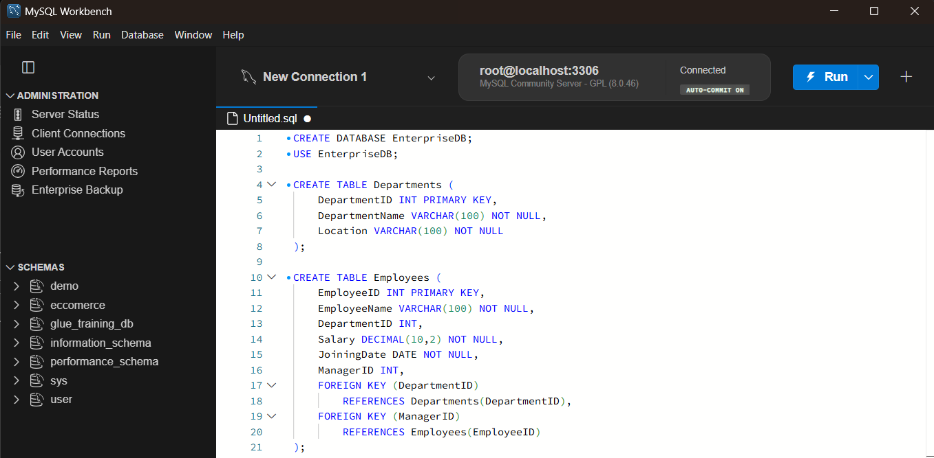

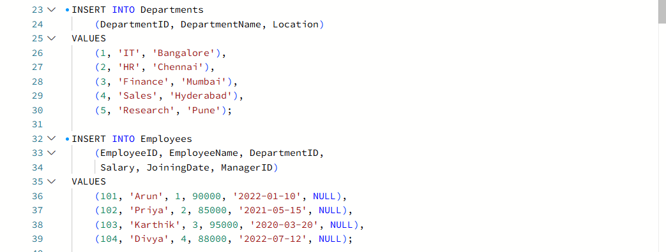

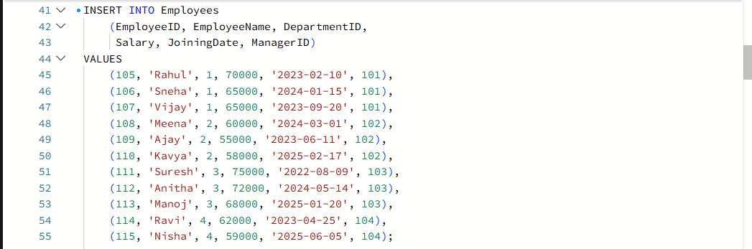
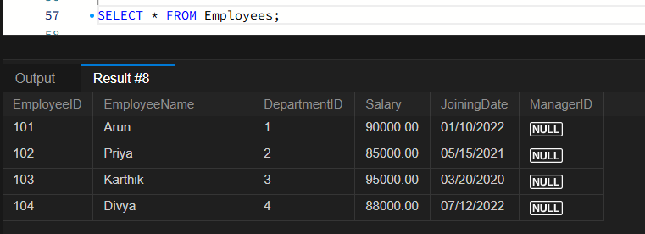
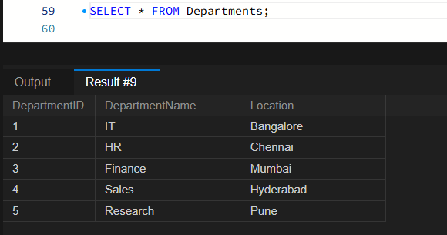

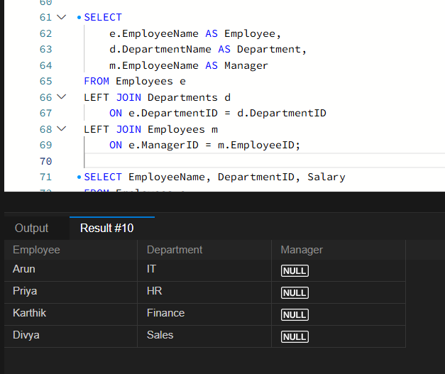

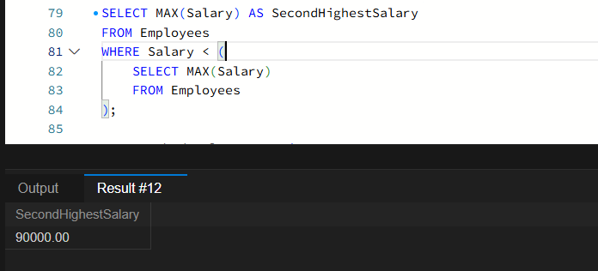
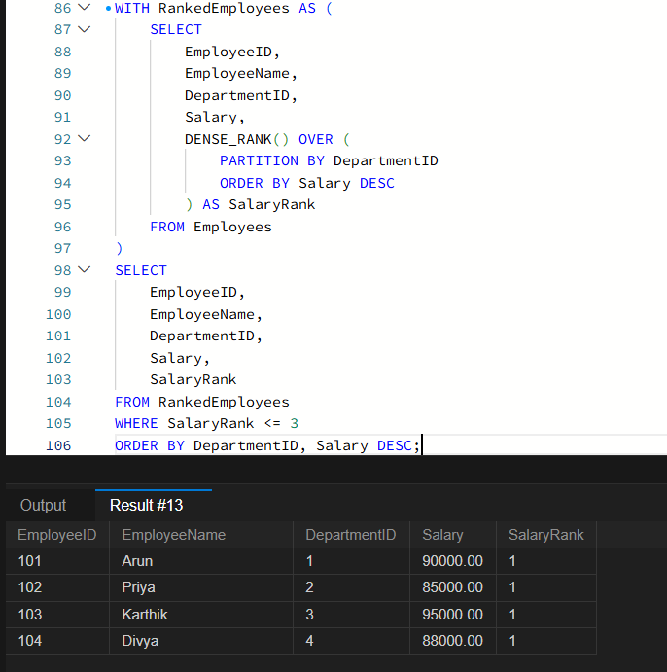

Question 2: Sales Analytics and Query Optimization

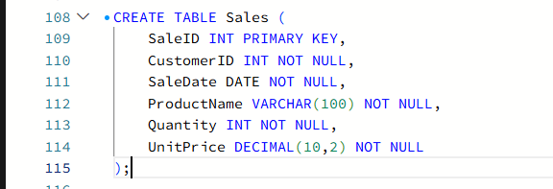

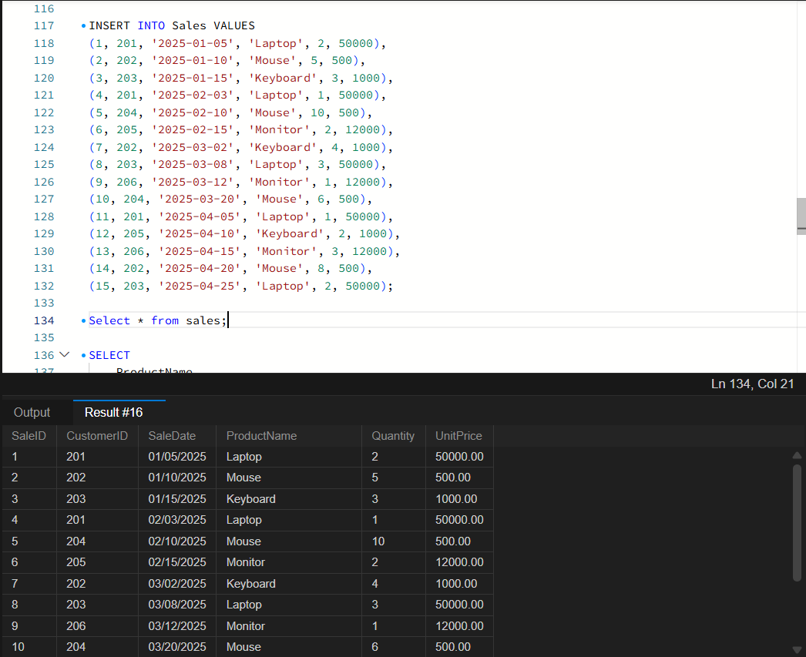

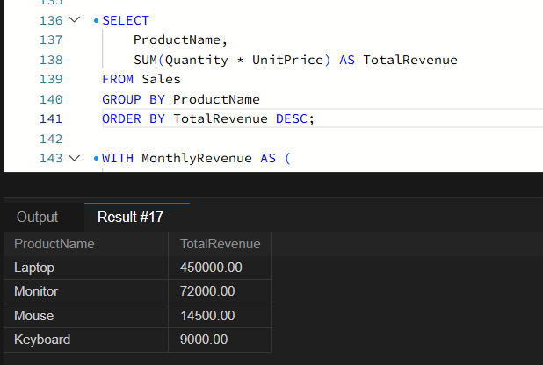

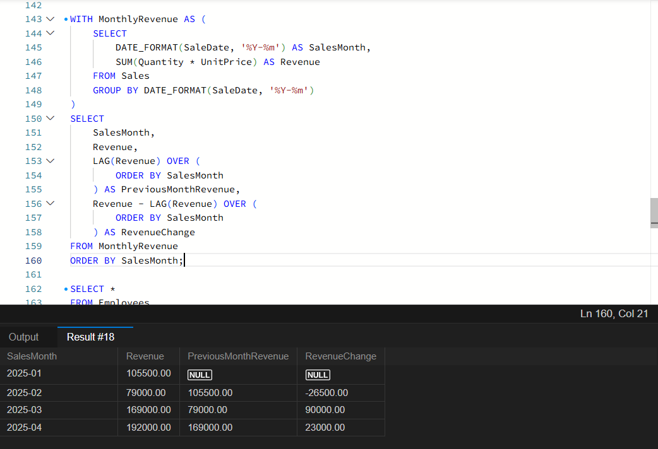

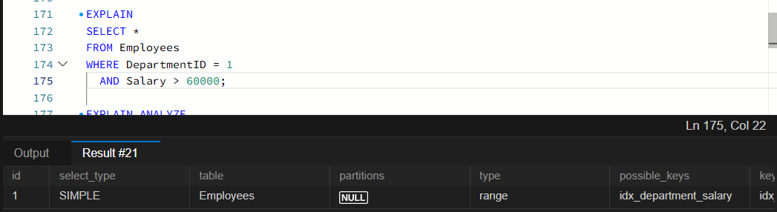

Question 3: SQL Troubleshooting
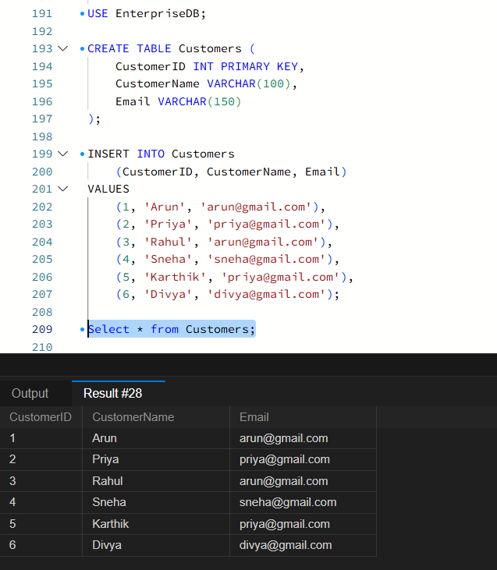

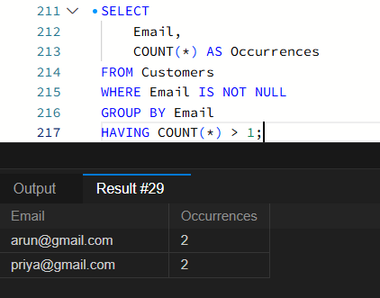

SECTION B: LINUX
Question 4: Log Analysis

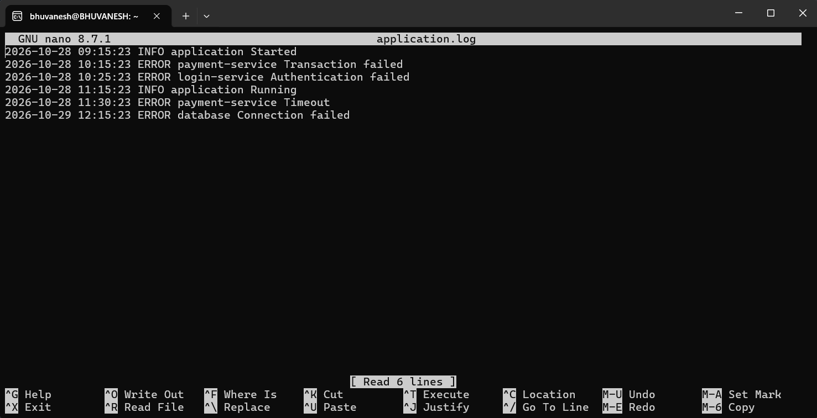

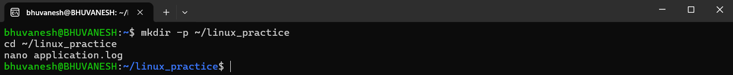

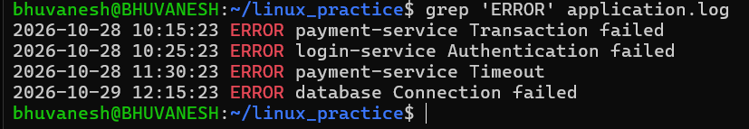

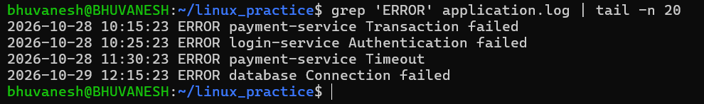

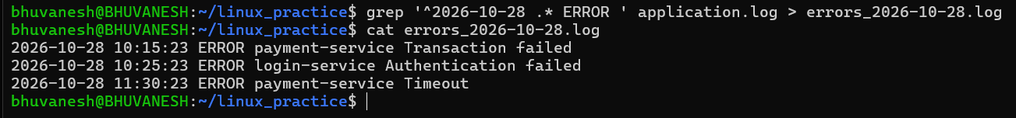

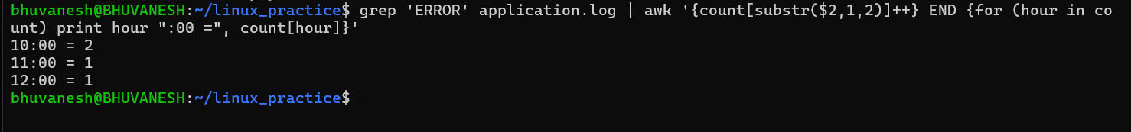

Question 5: Permissions and System Troubleshooting
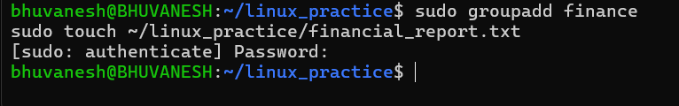

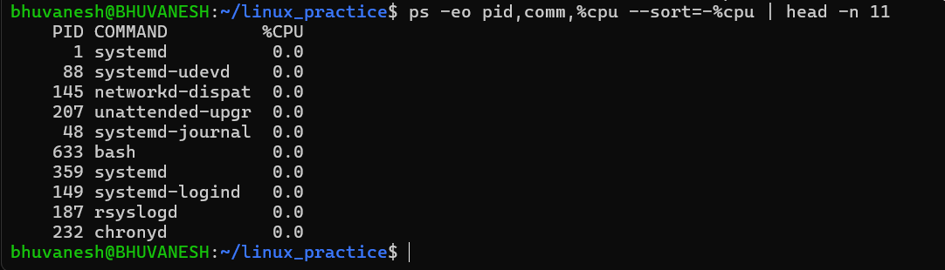

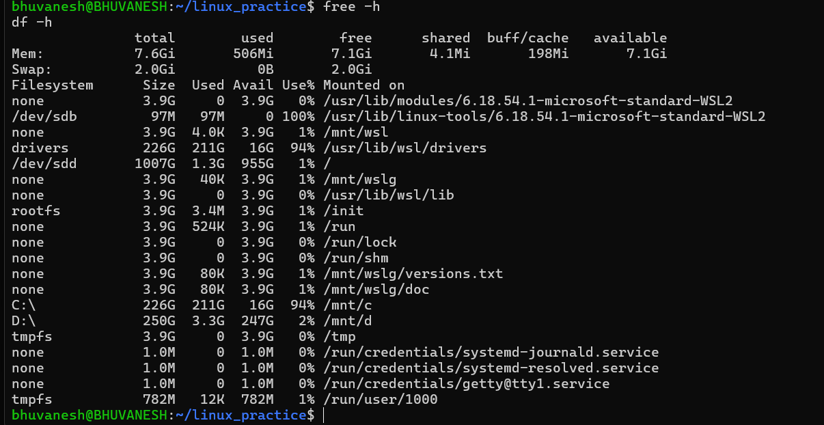

Question 6: Bash Scripting

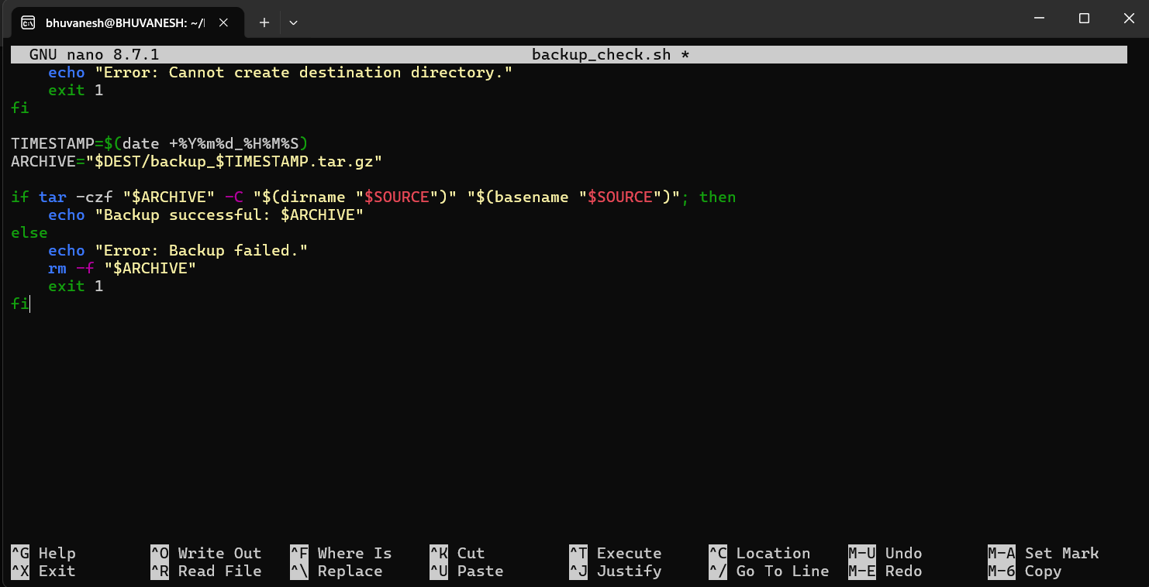

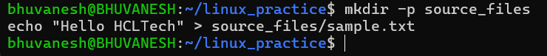

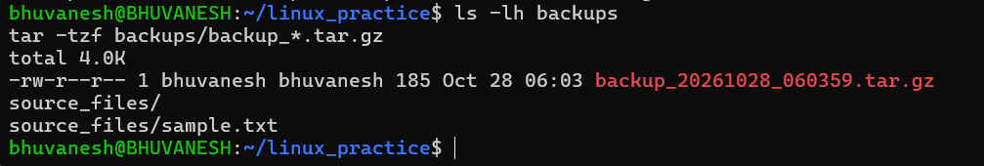

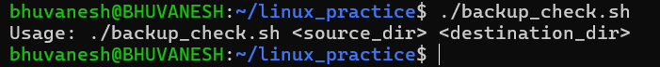

SECTION C: PYSPARK DATA ENGINEERING
Question 7: PySpark DataFrame Operations

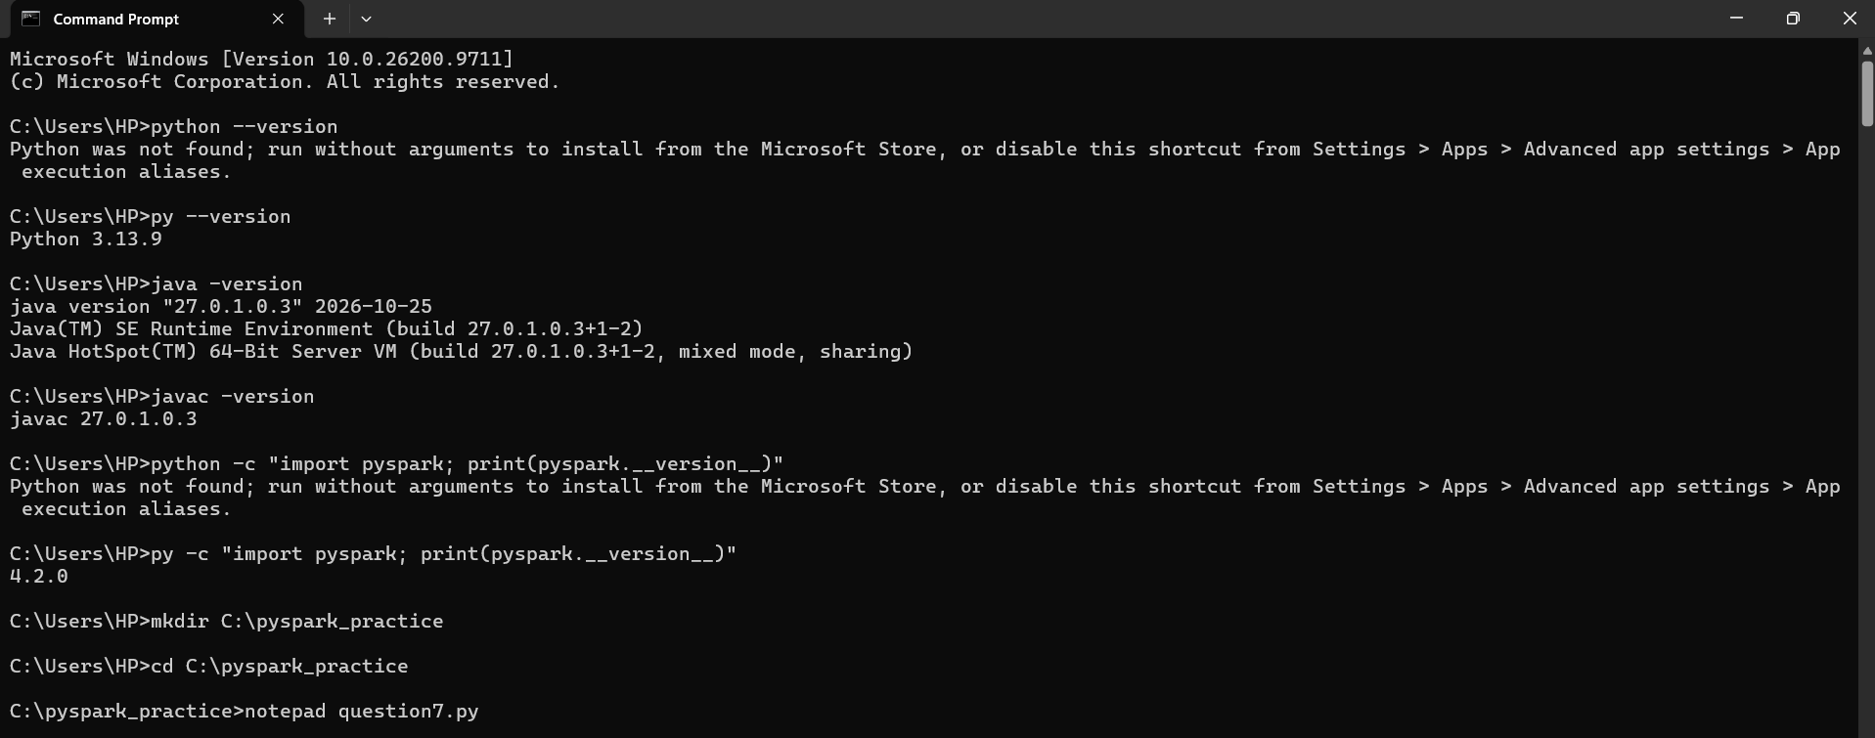

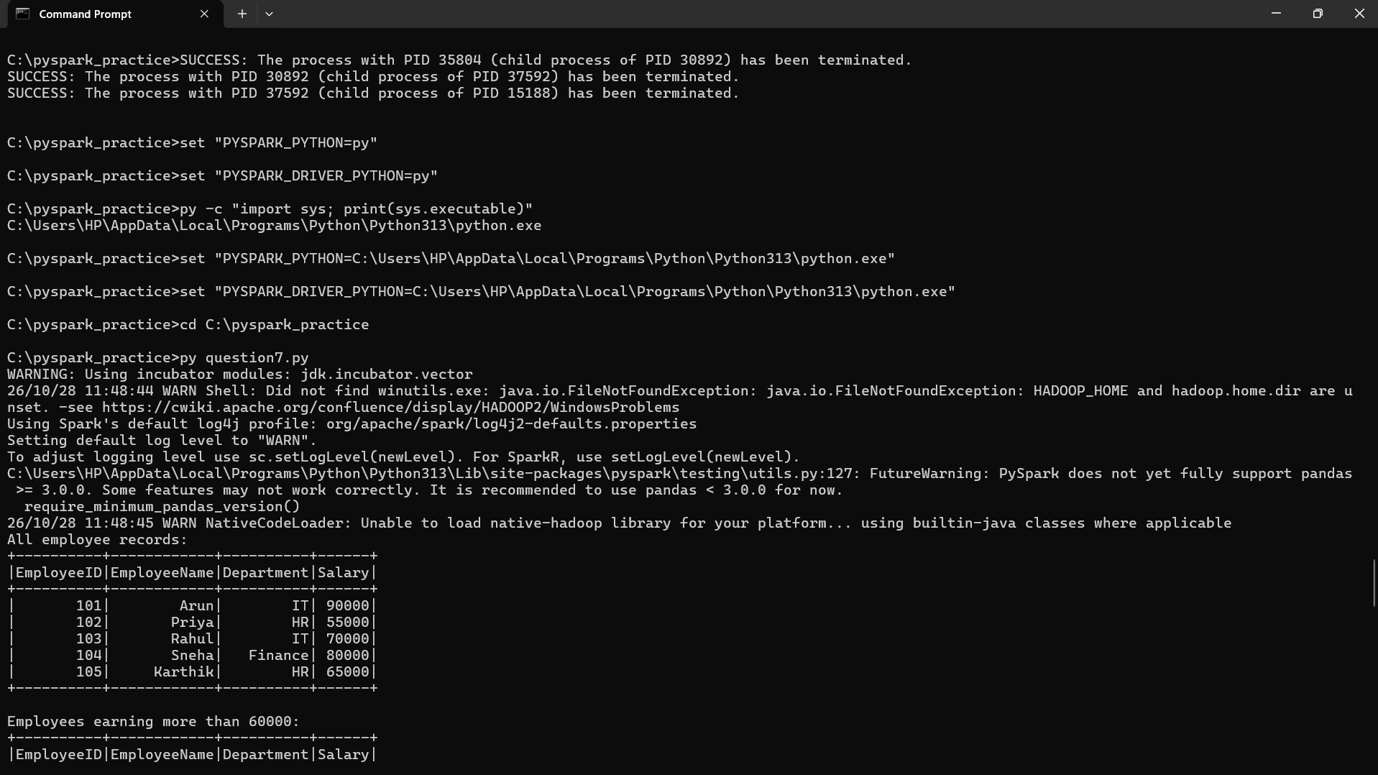

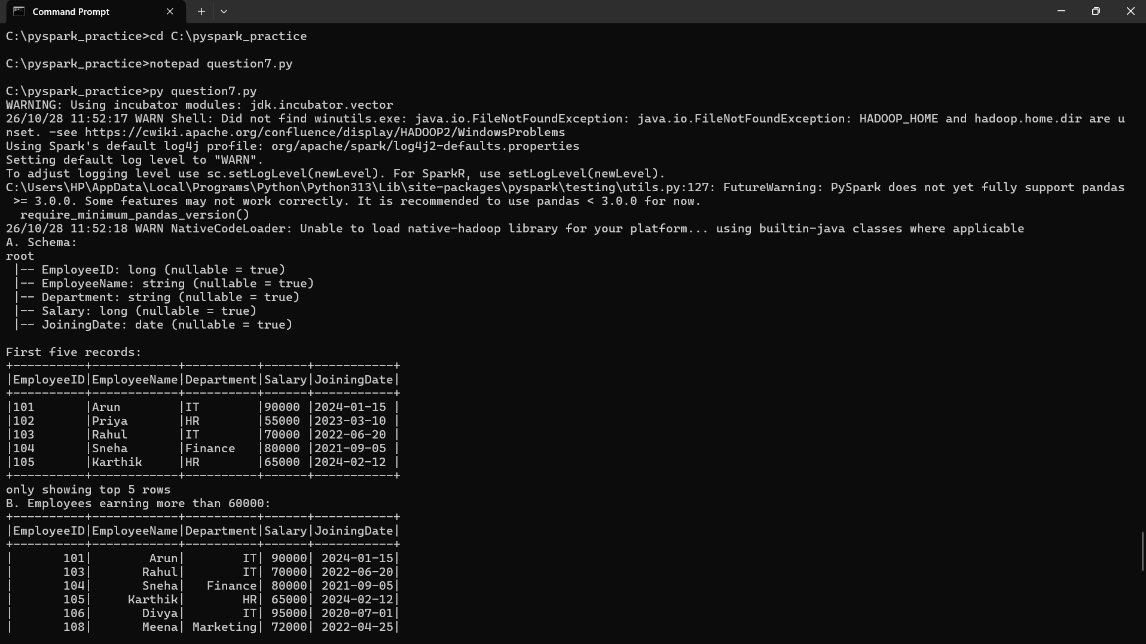
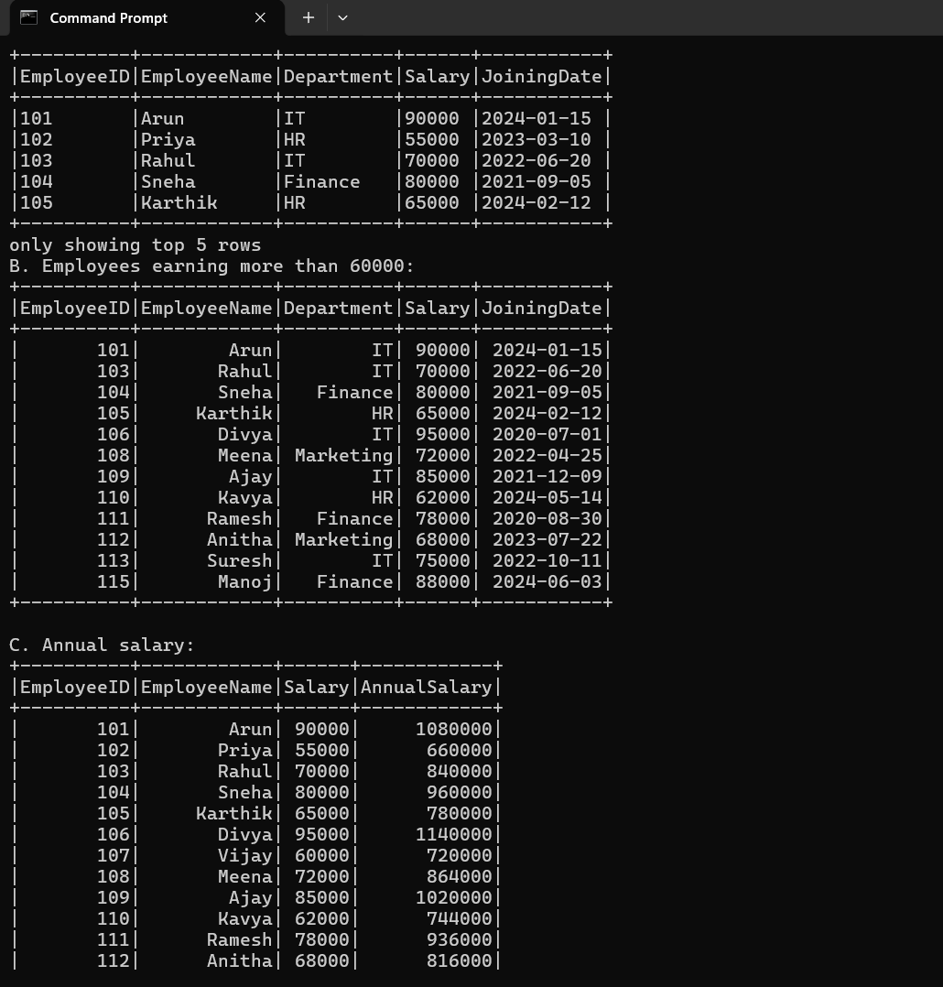

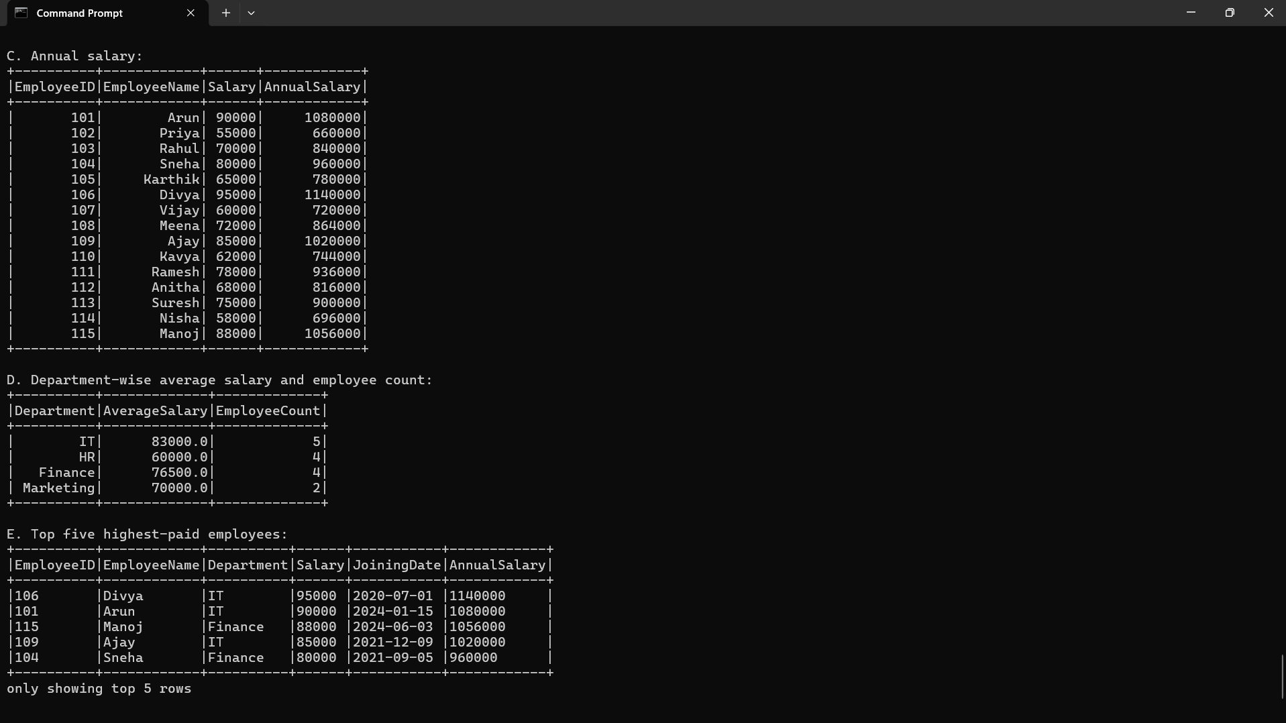

Question 8: Data Cleaning and Aggregation

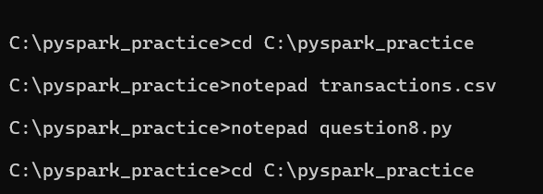
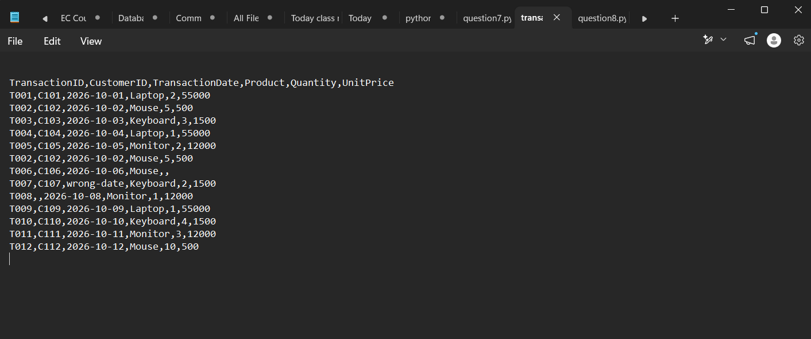

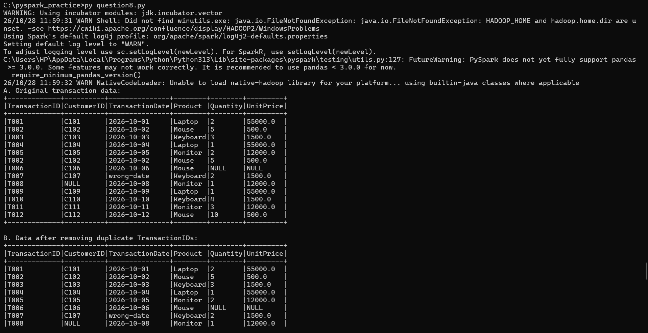
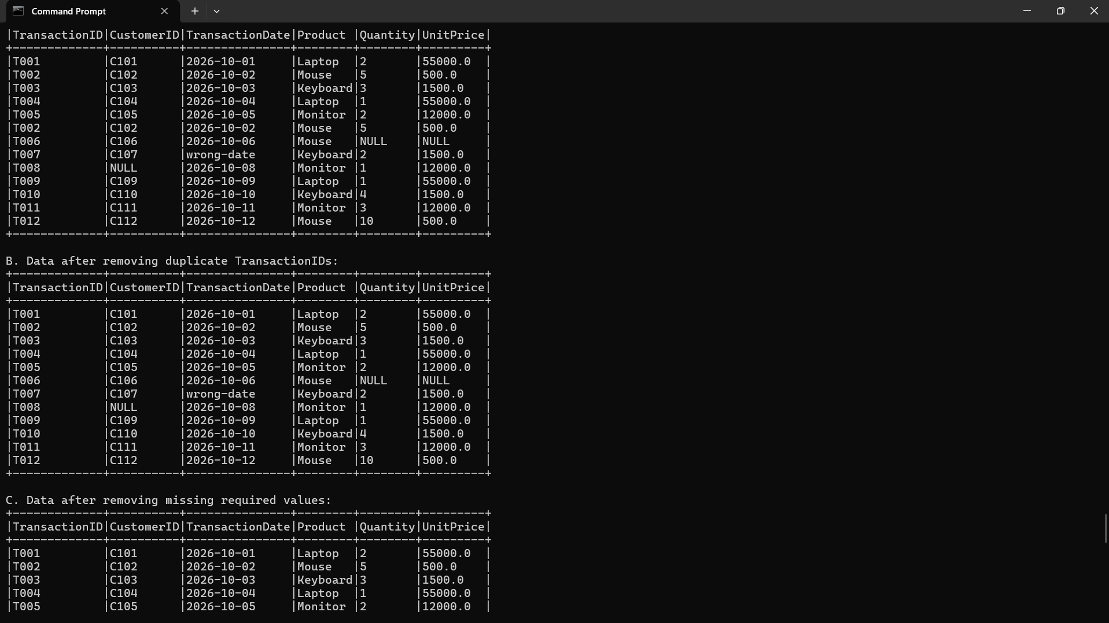

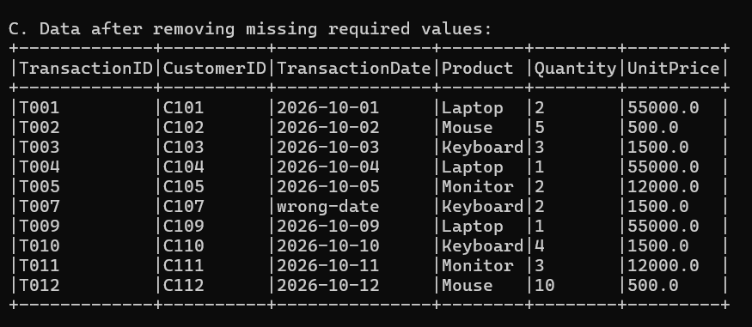

Question 9: PySpark Joins and Performance

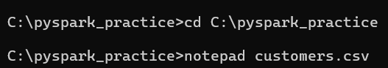
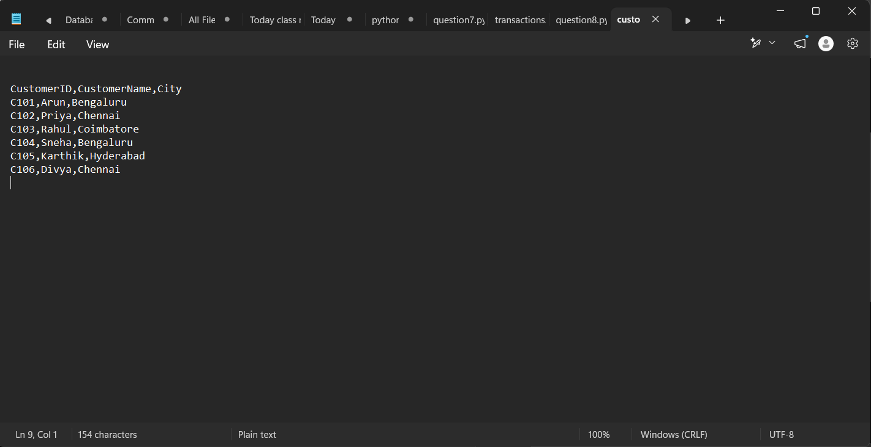

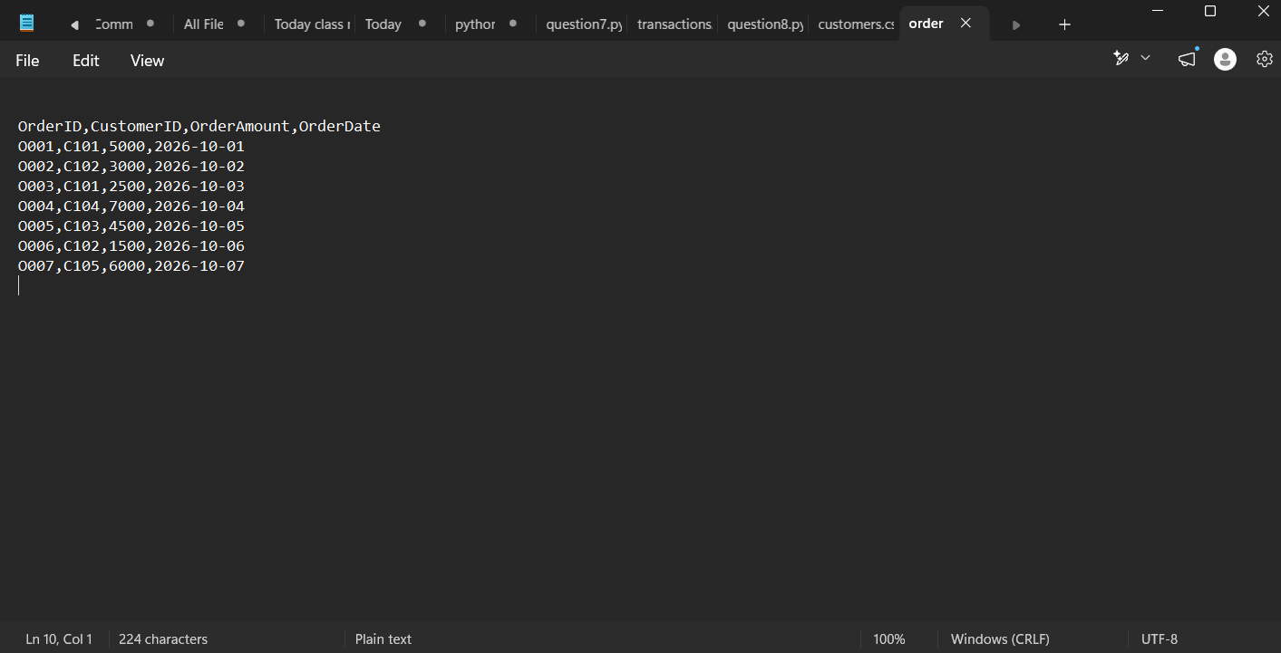

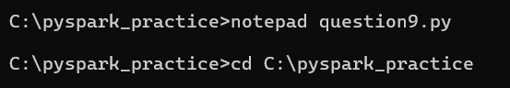

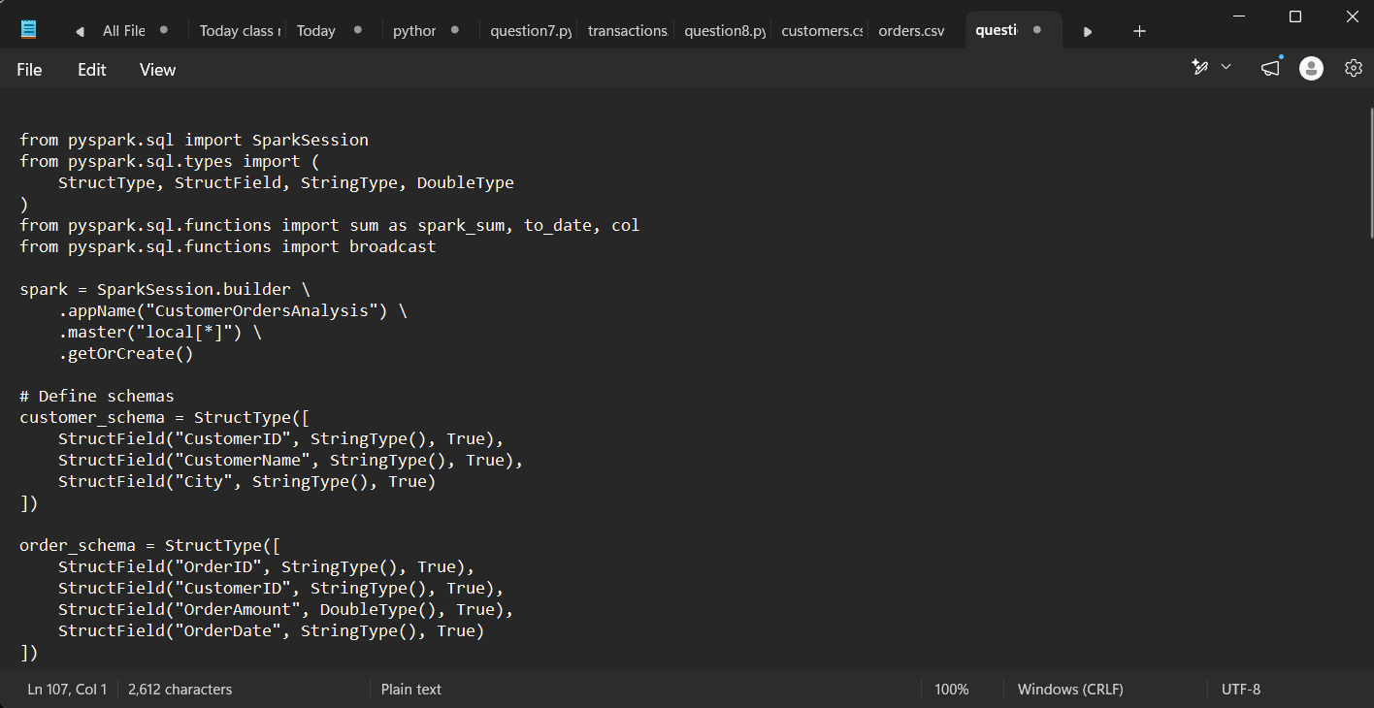

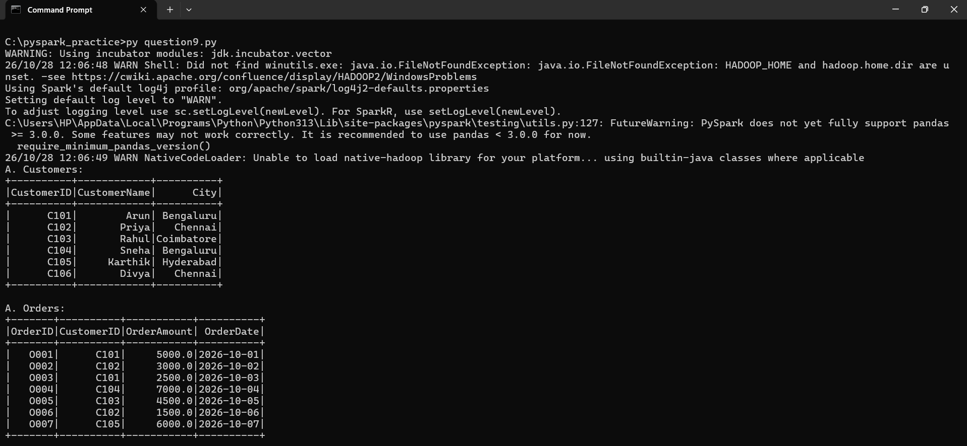

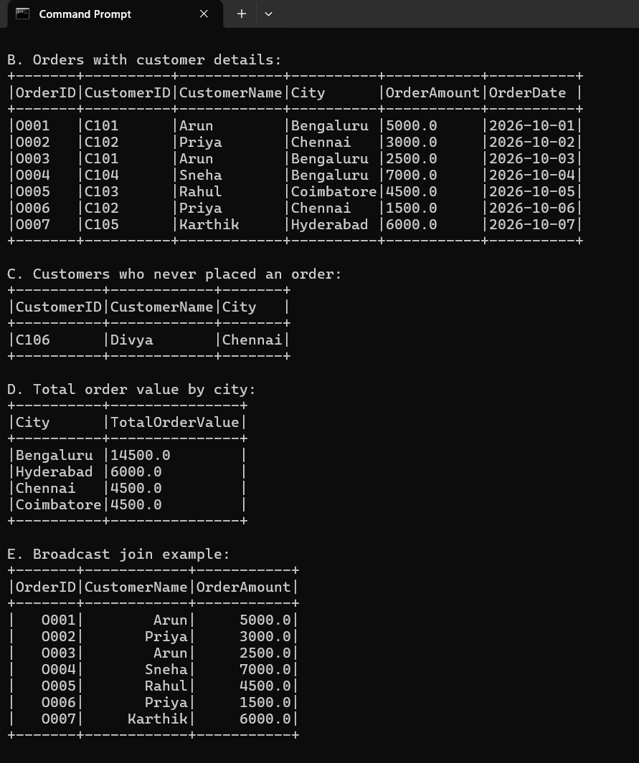

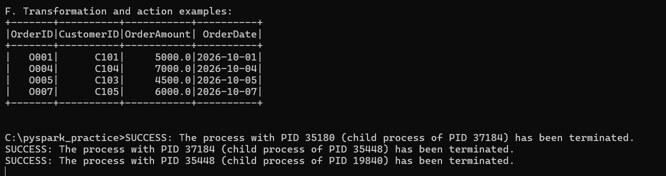

SECTION D: AWS CLOUD SERVICES
Question 10: S3 and IAM Security

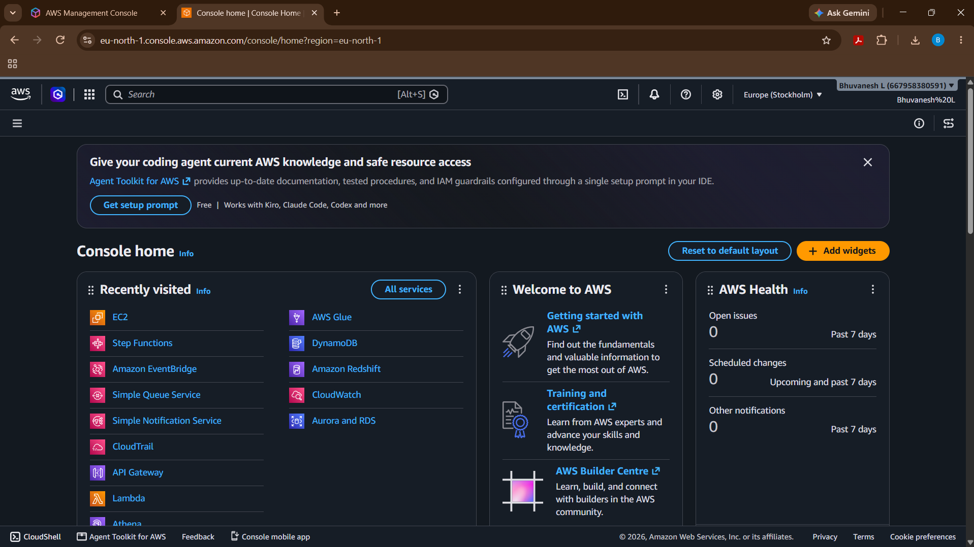

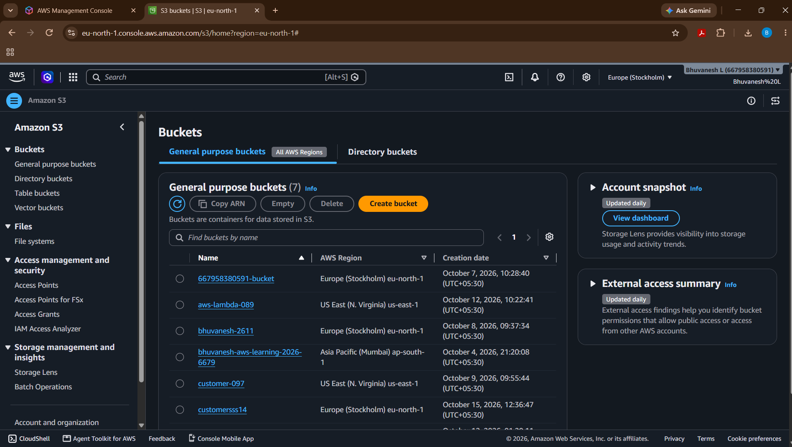

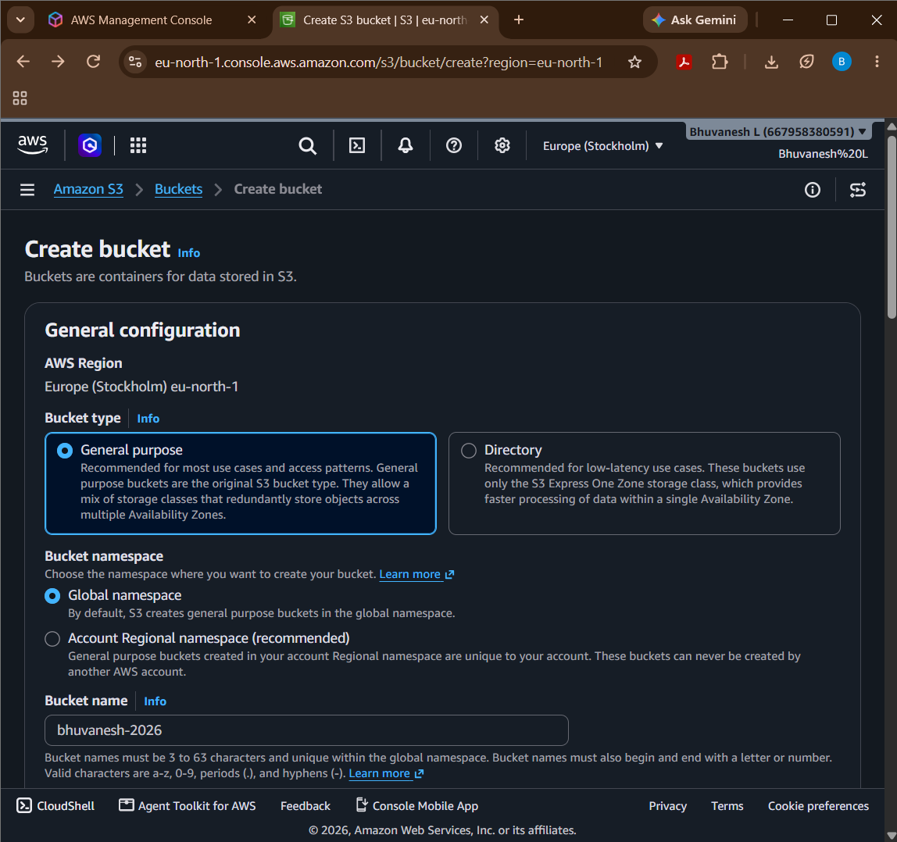

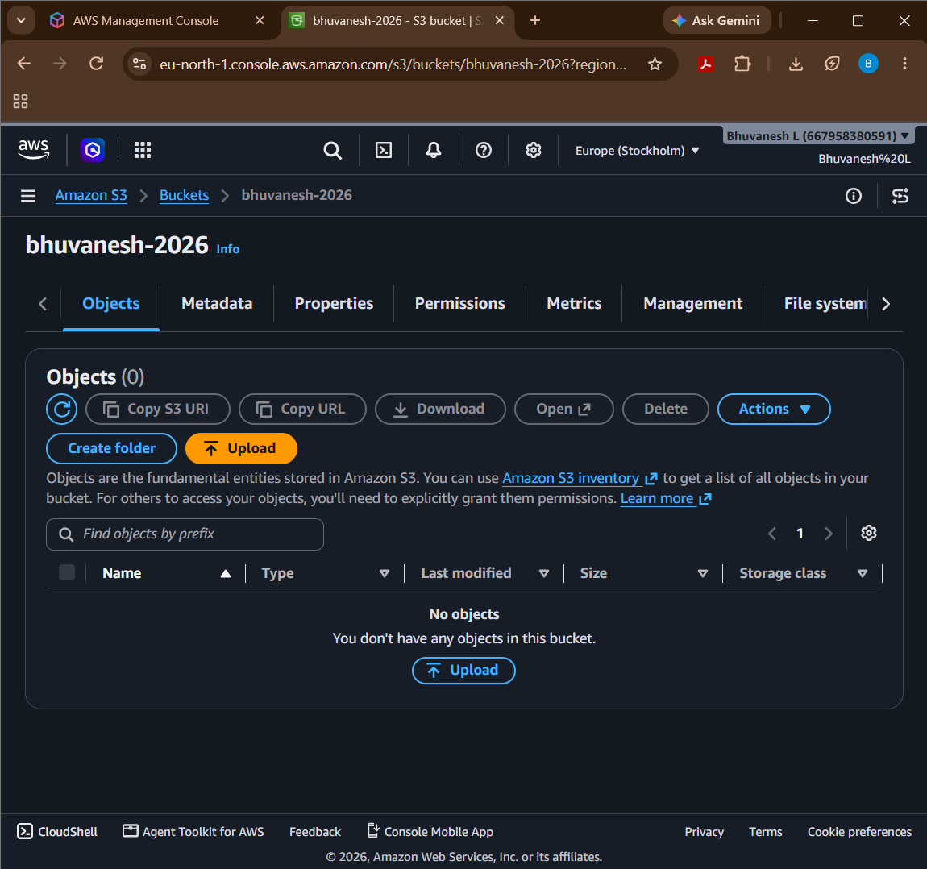

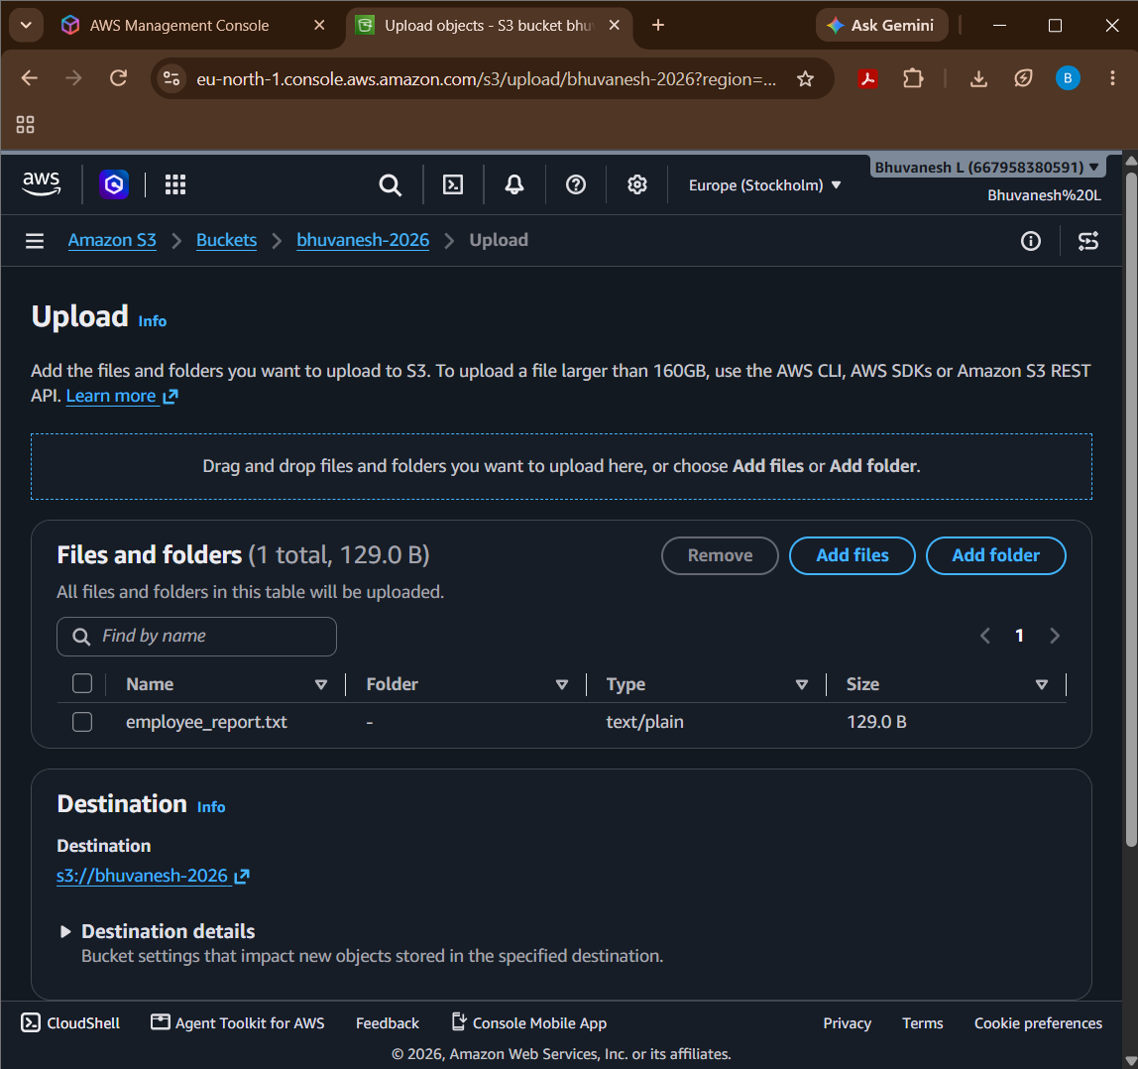

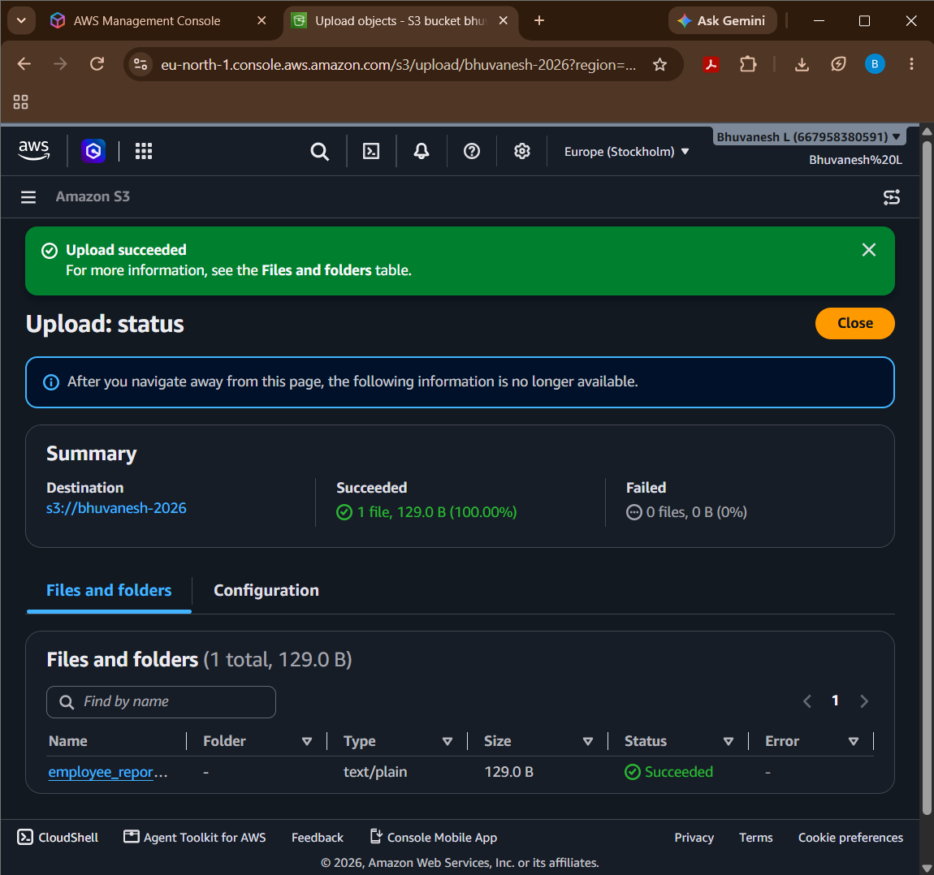

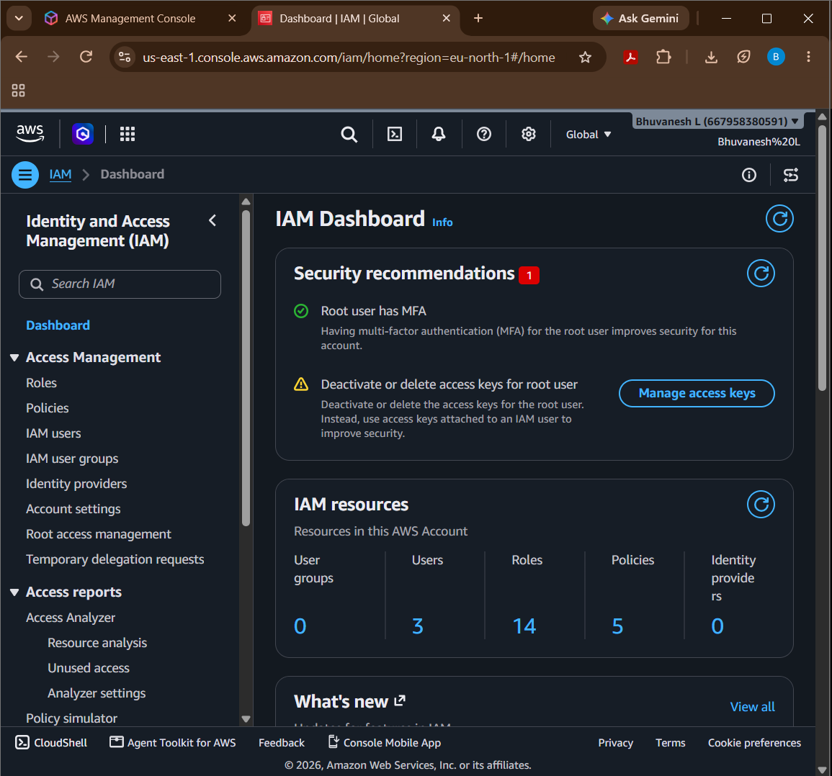

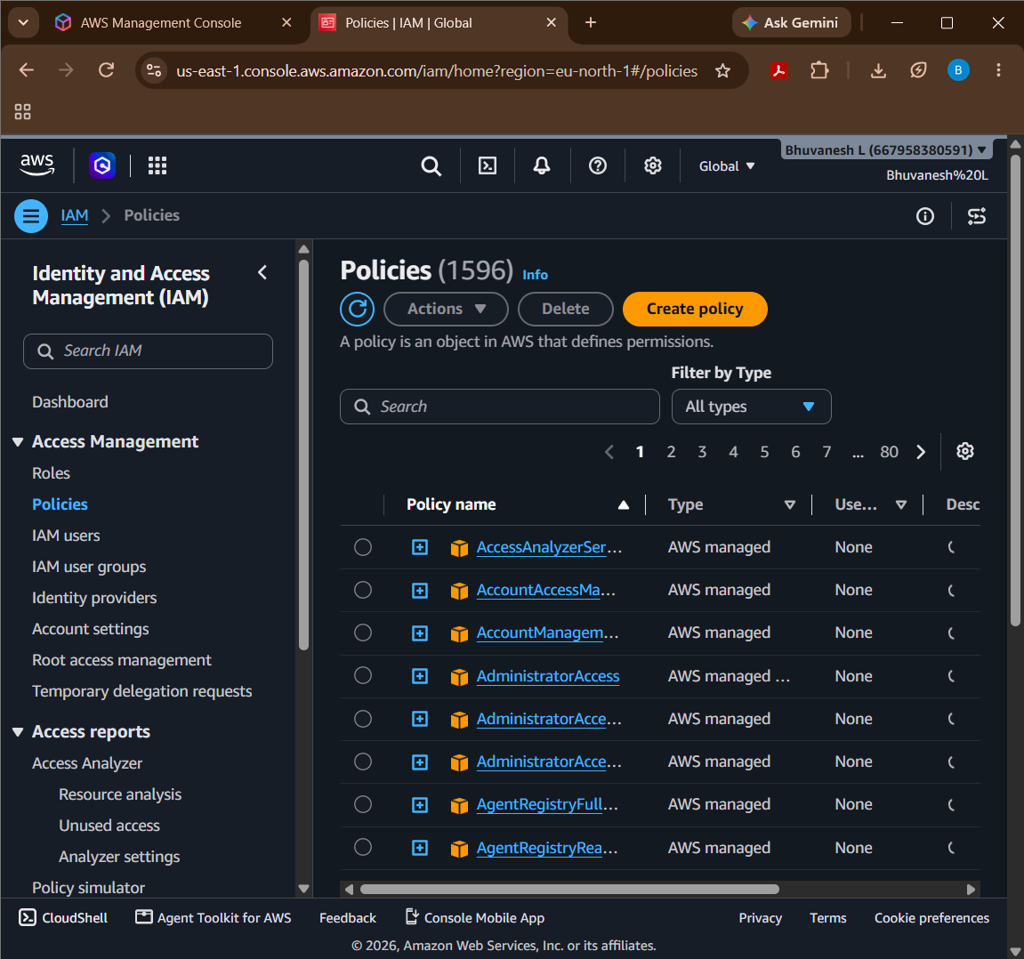

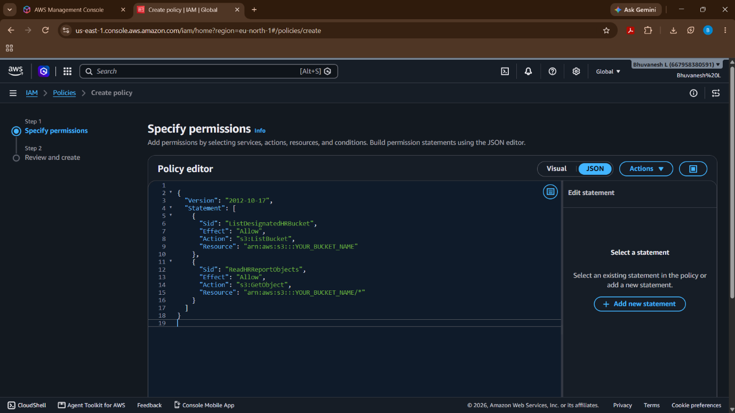

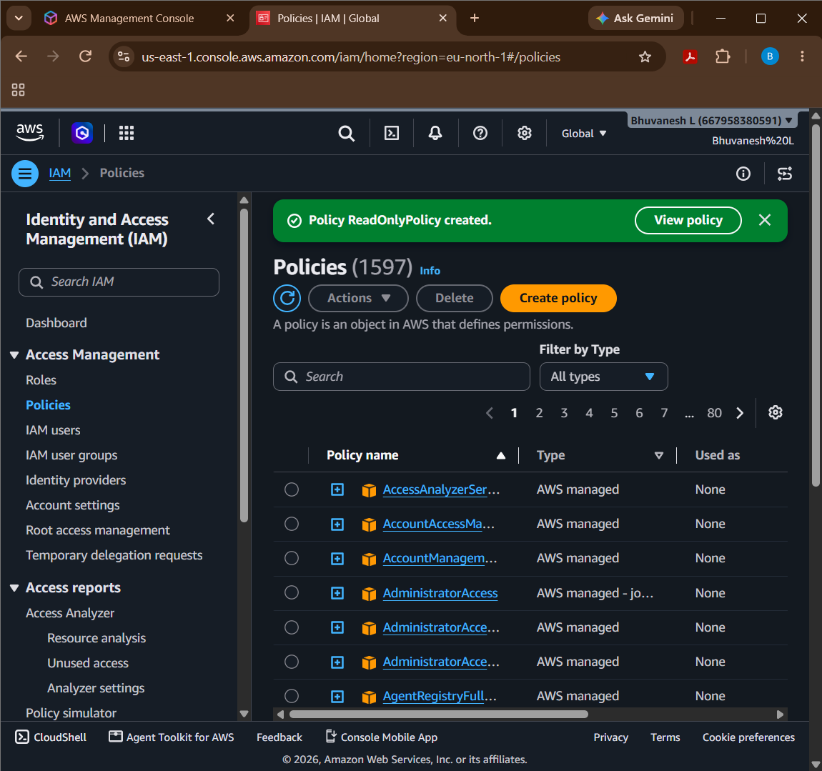

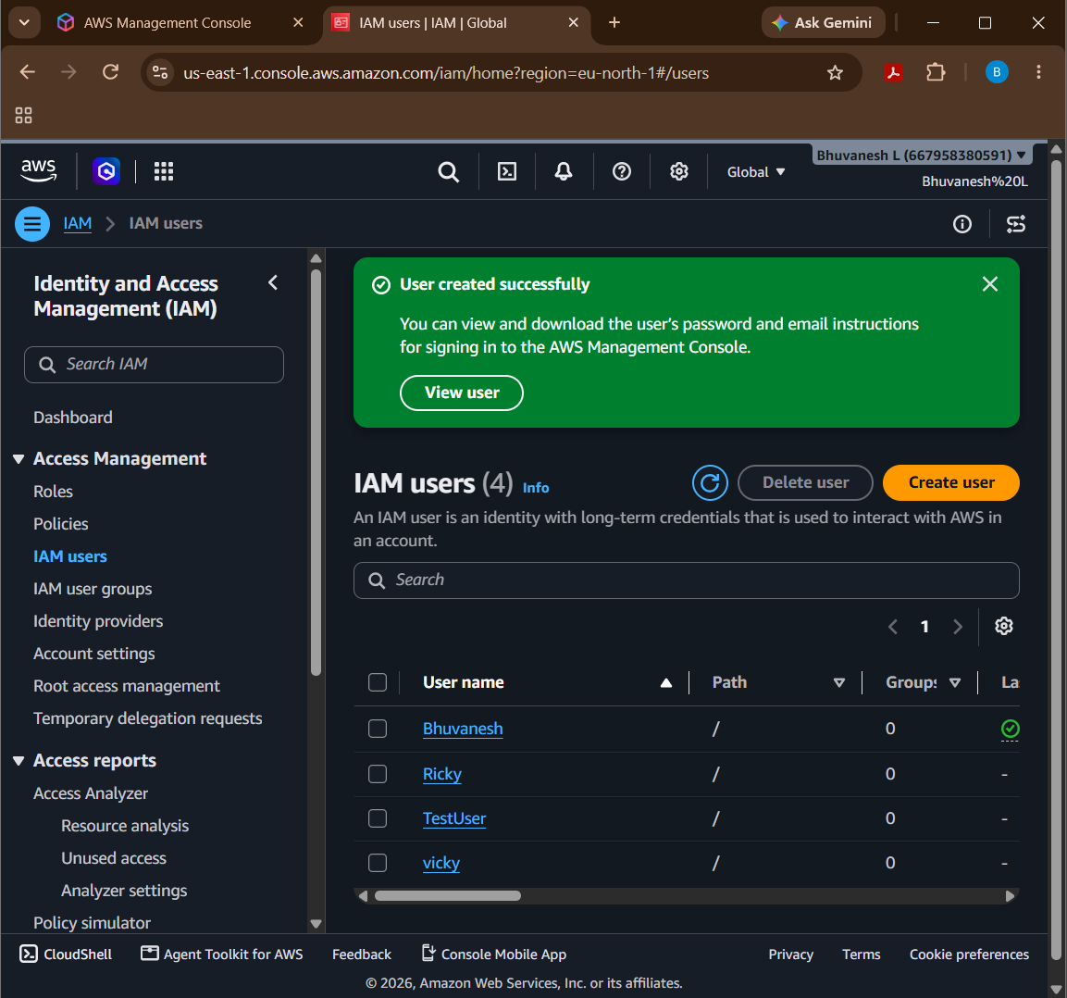

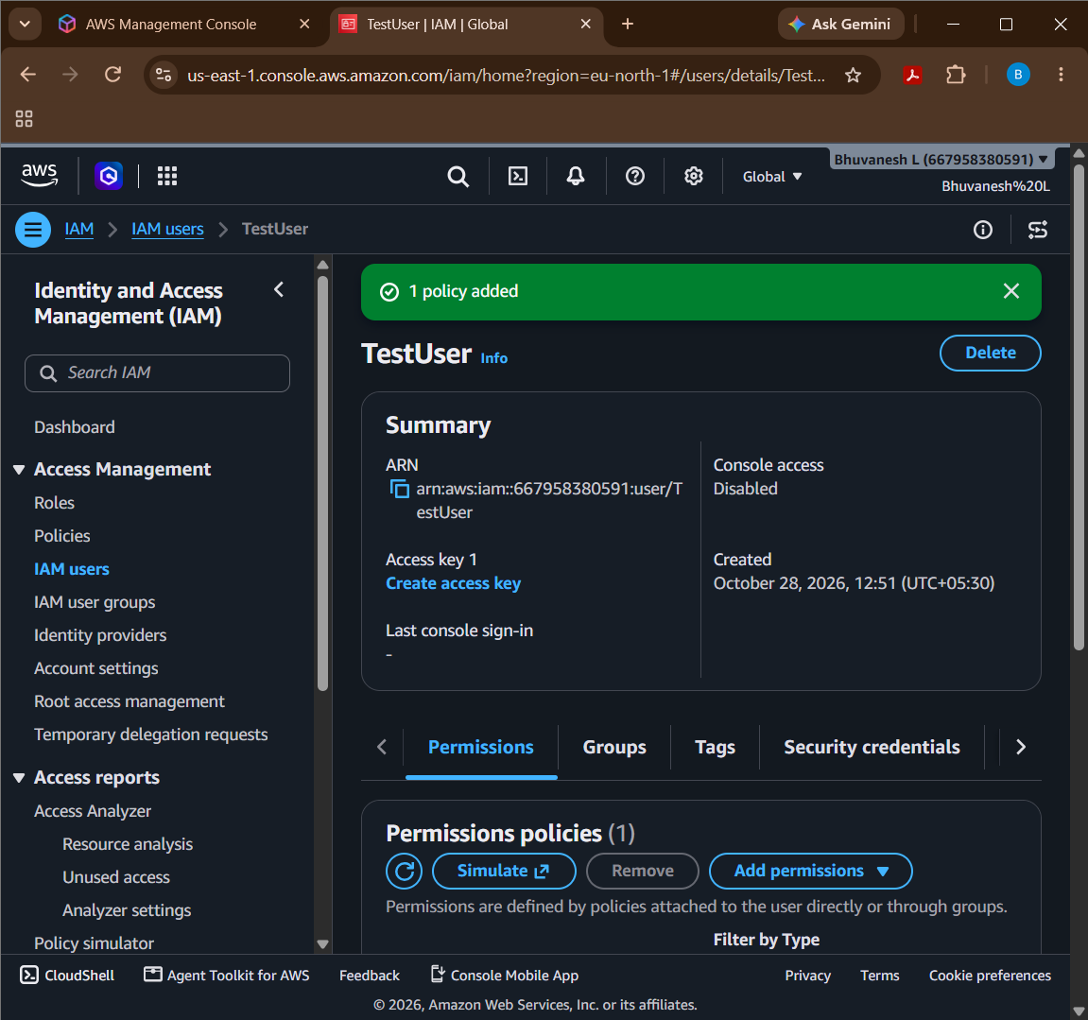

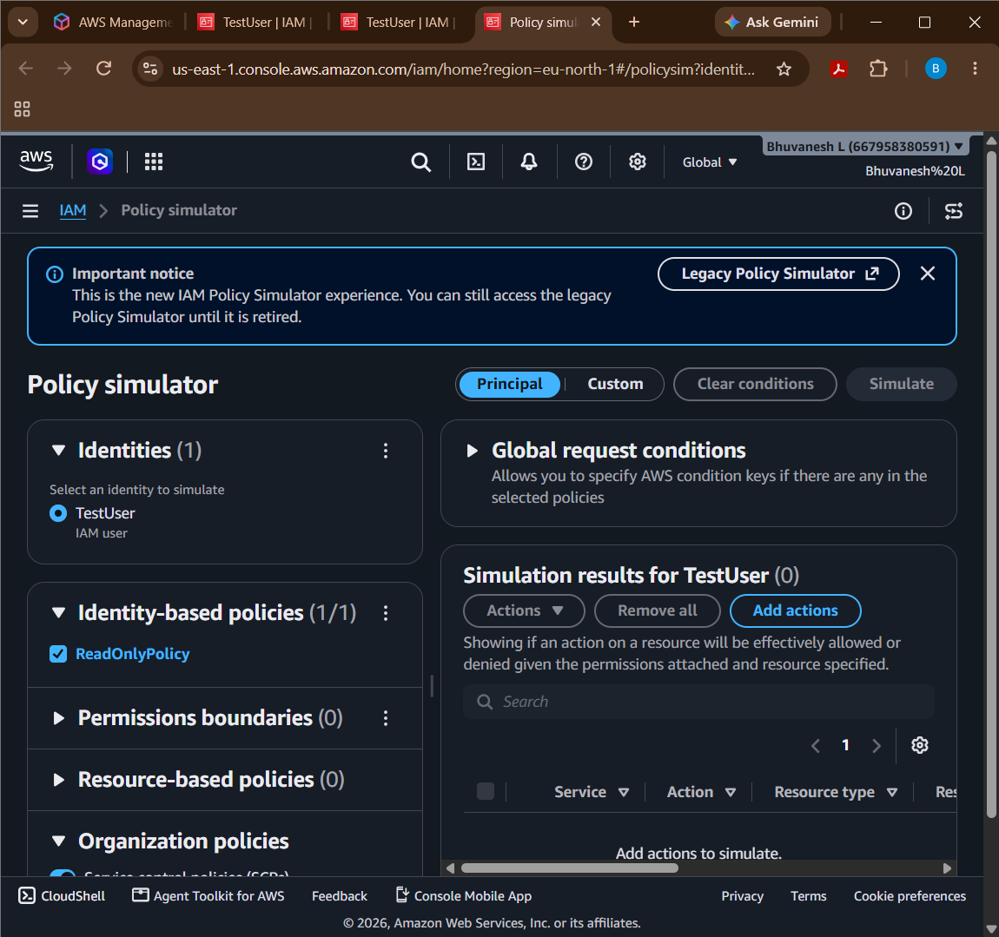

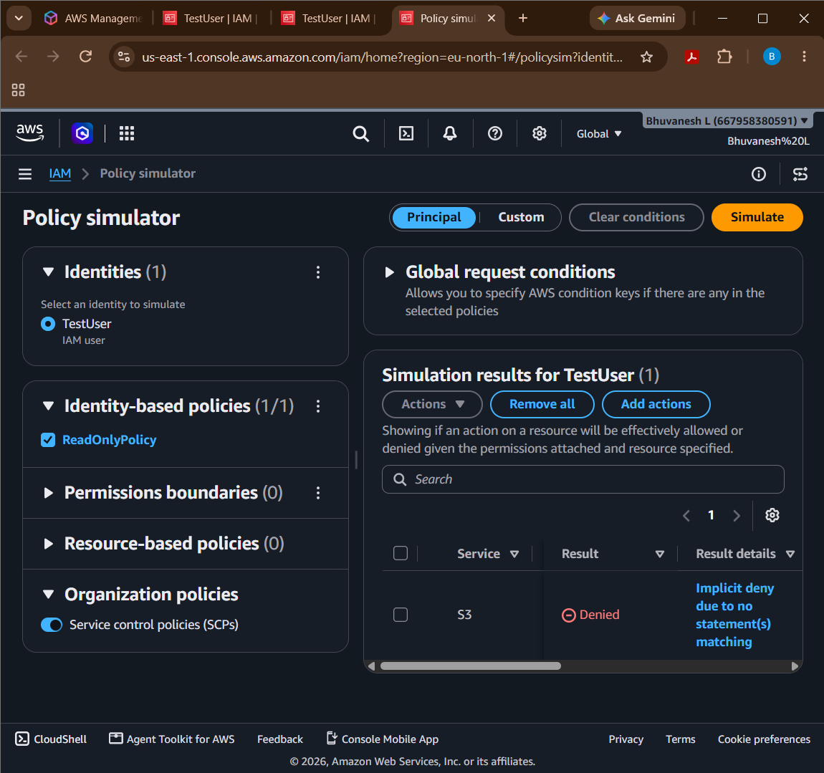

Question 11: EC2 Troubleshooting and CloudWatch
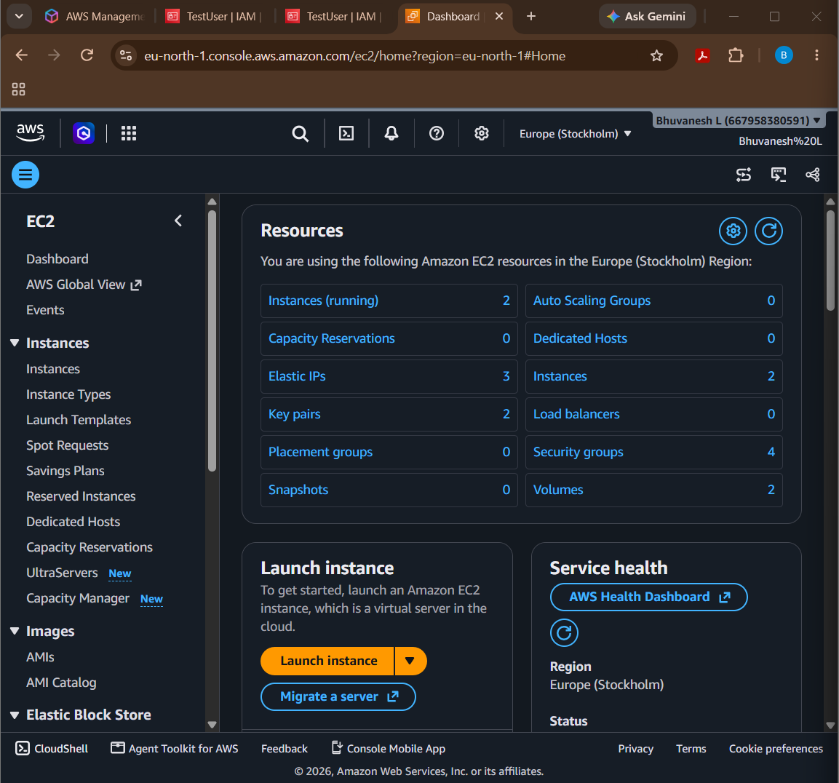

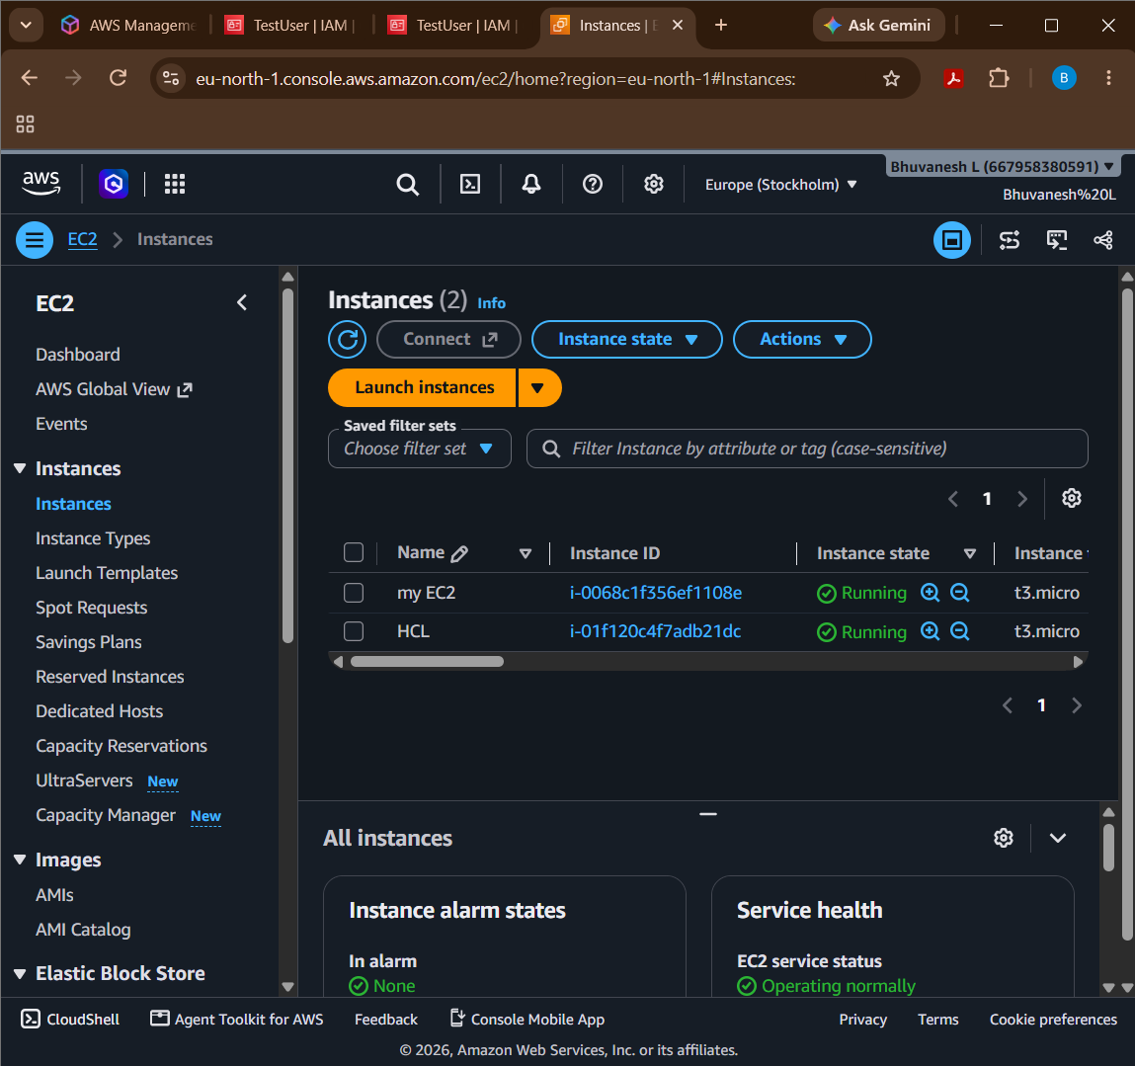

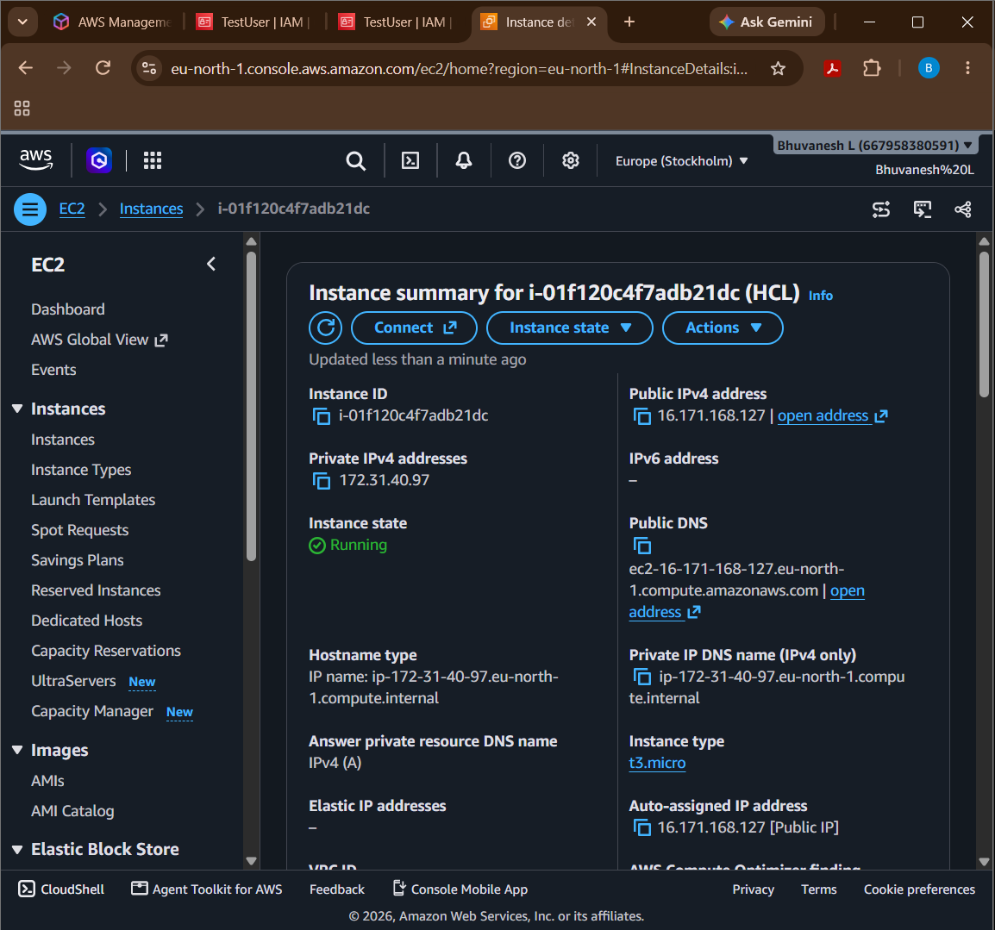

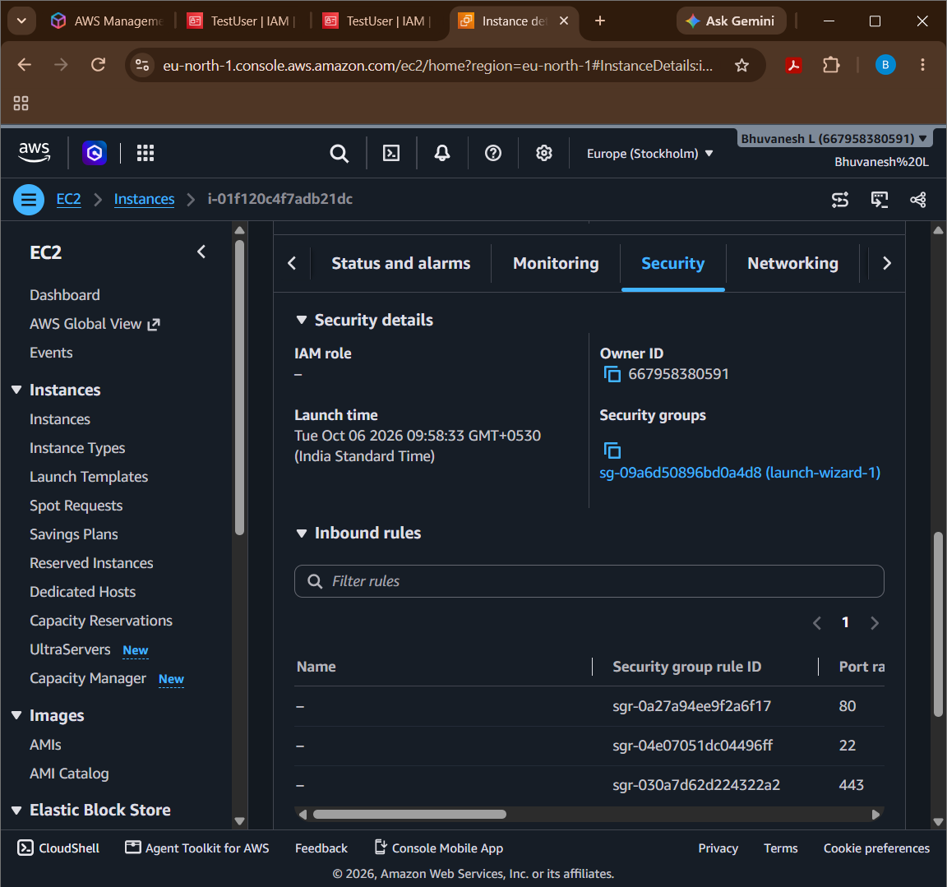

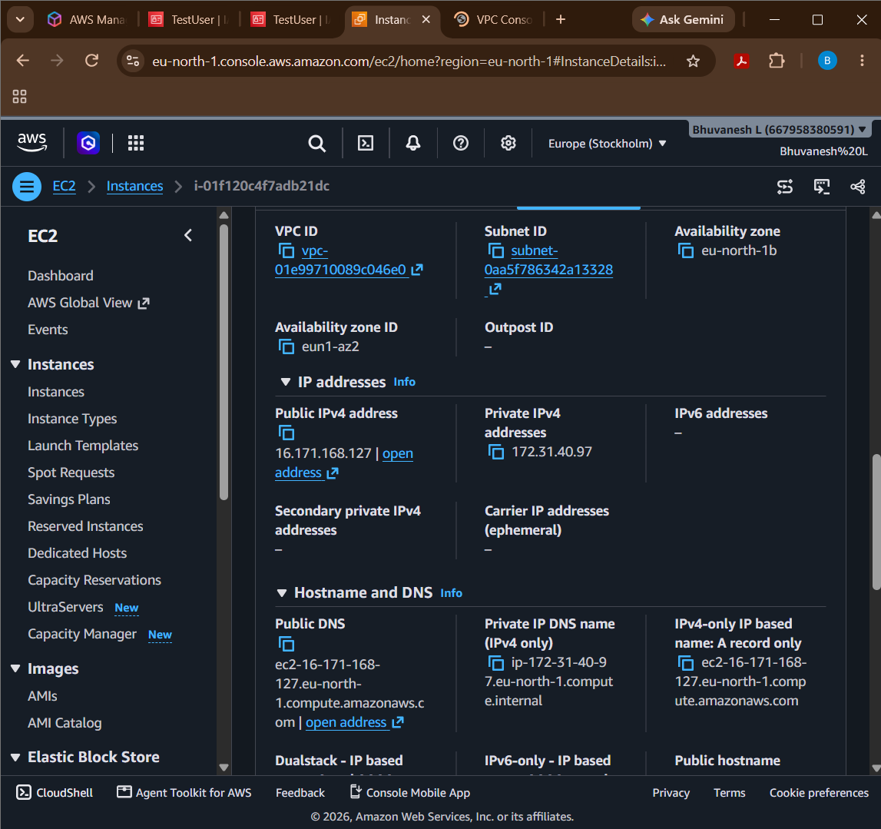

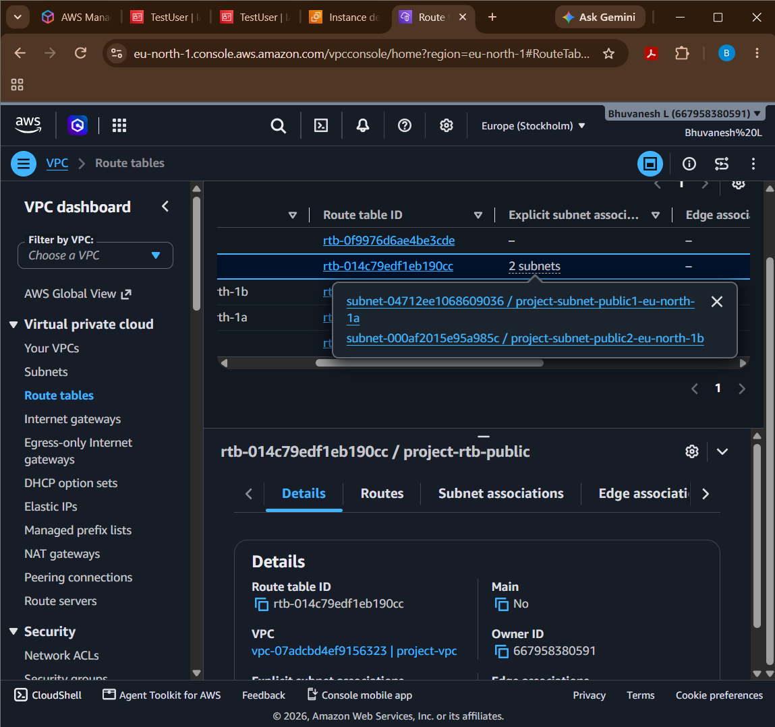

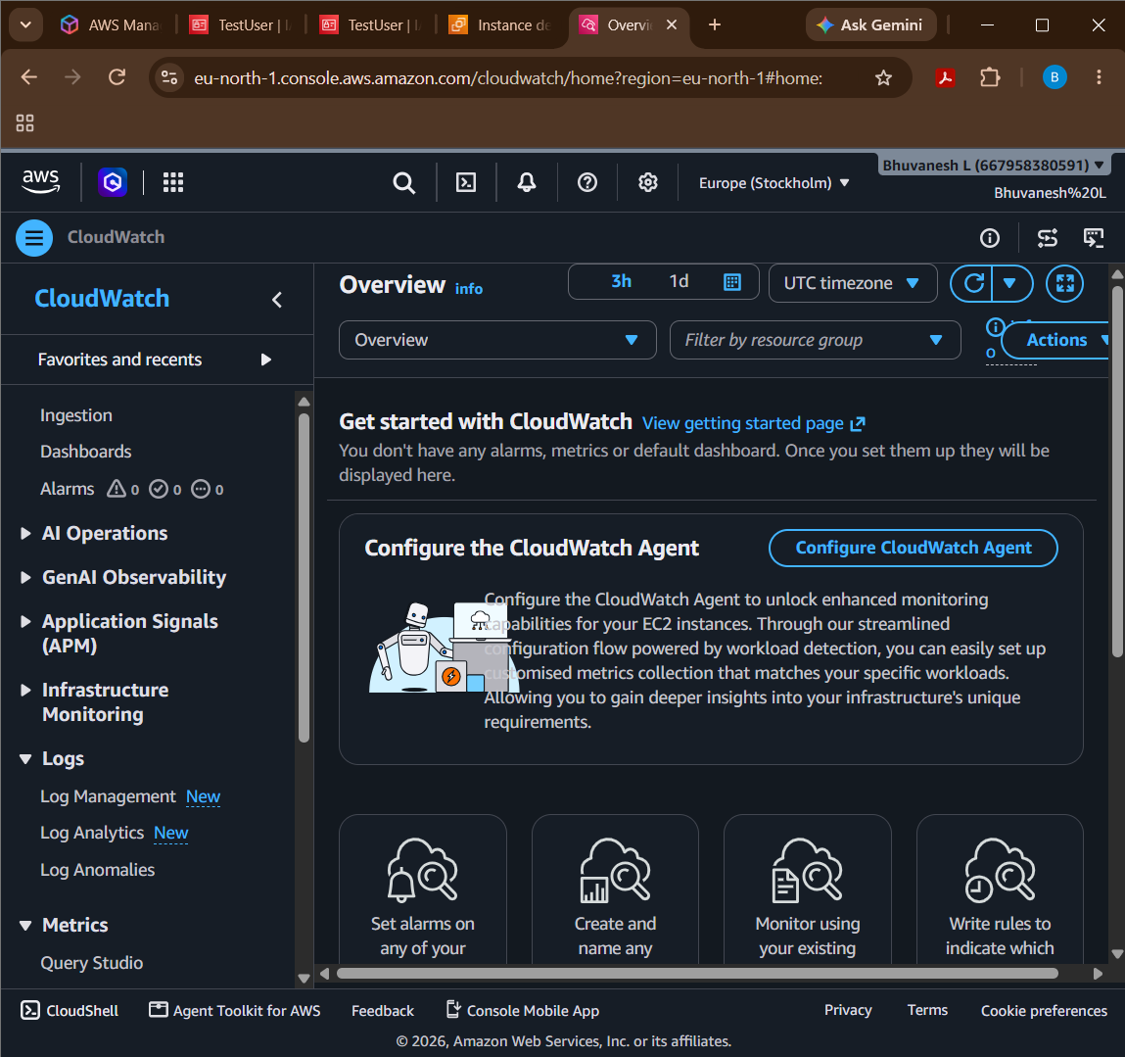

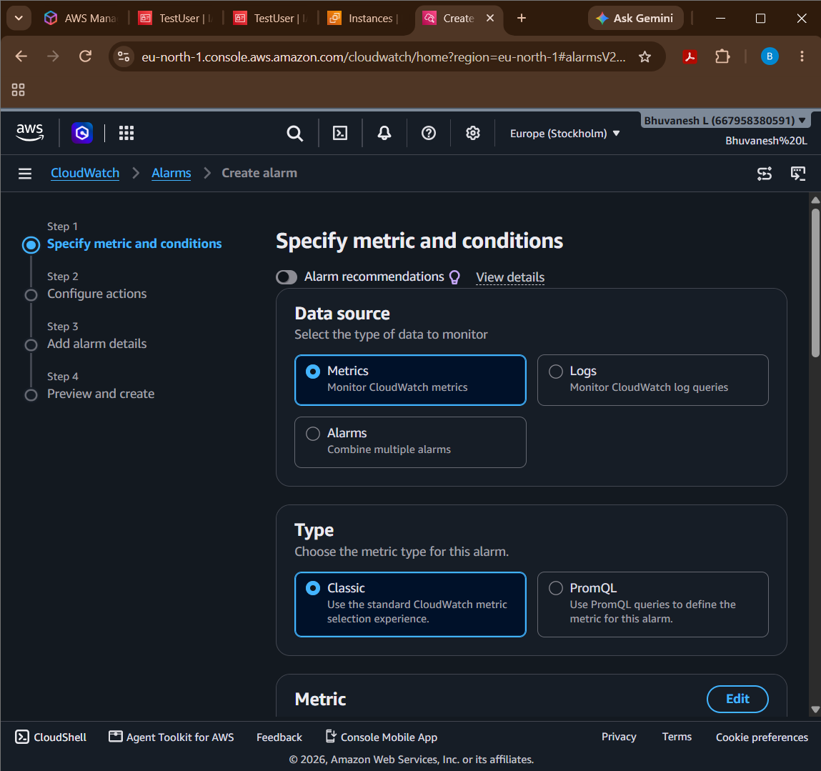

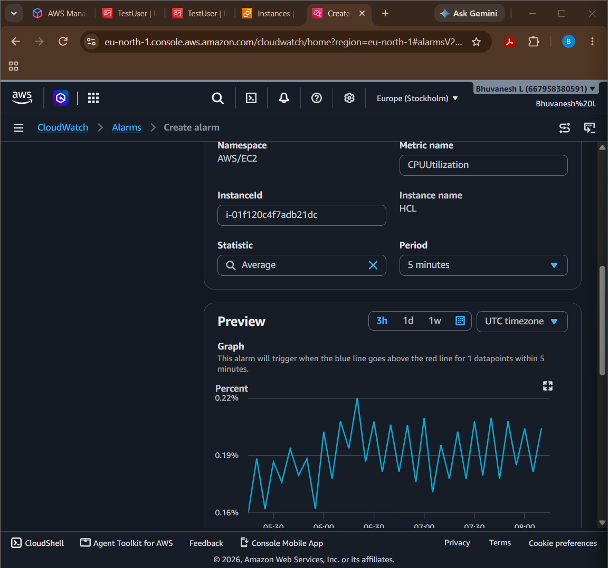

Question 12: Event-Driven Processing
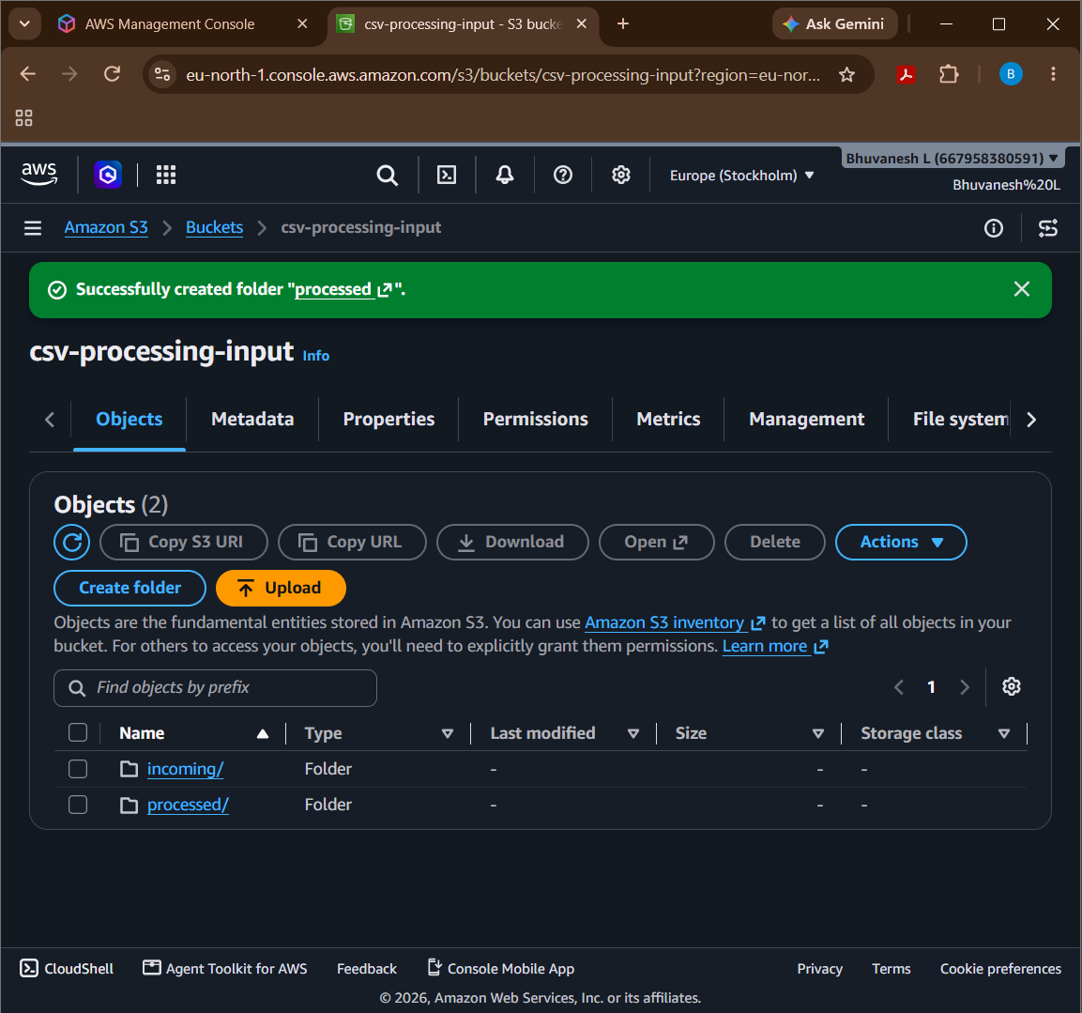

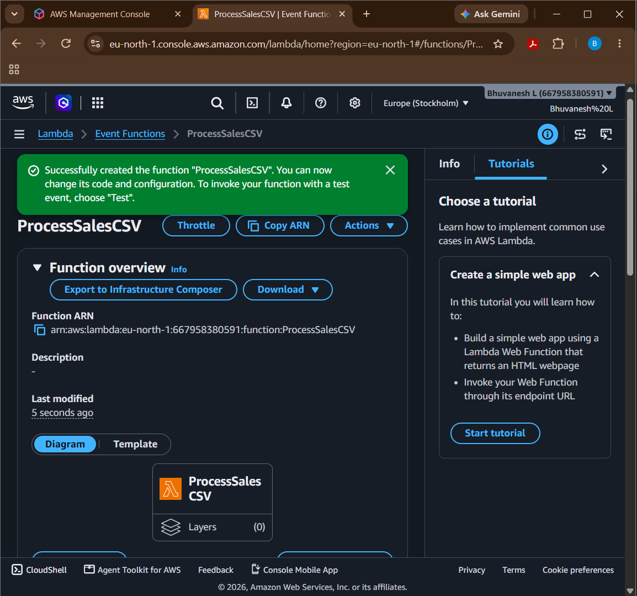

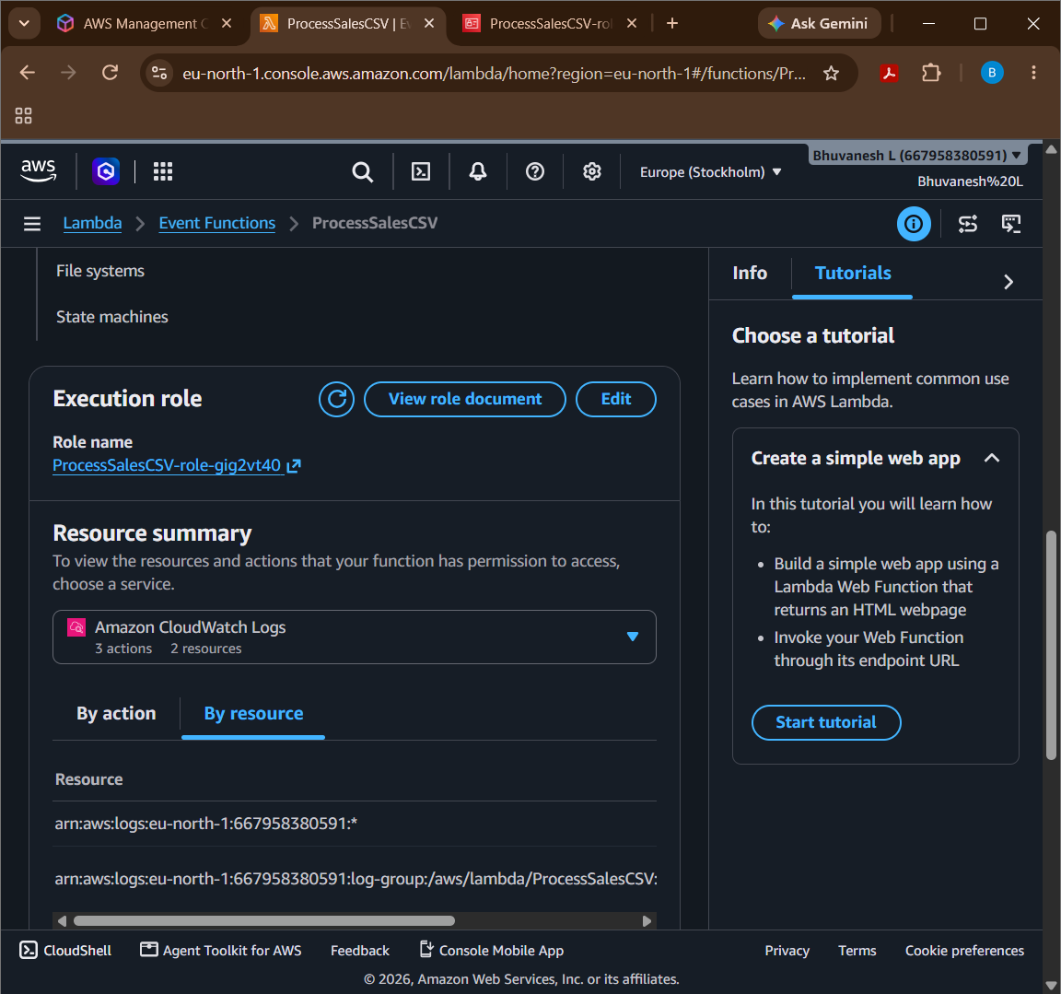

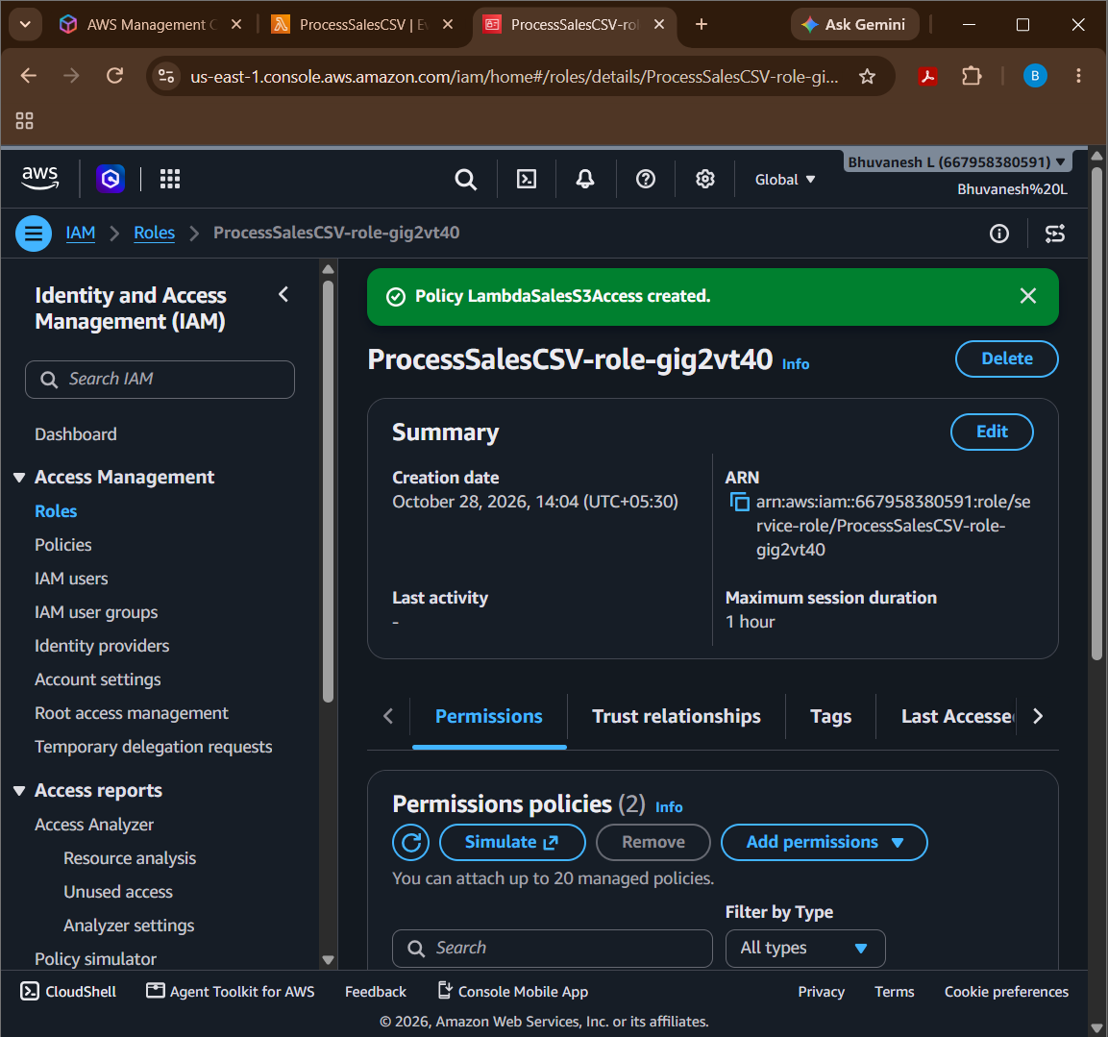

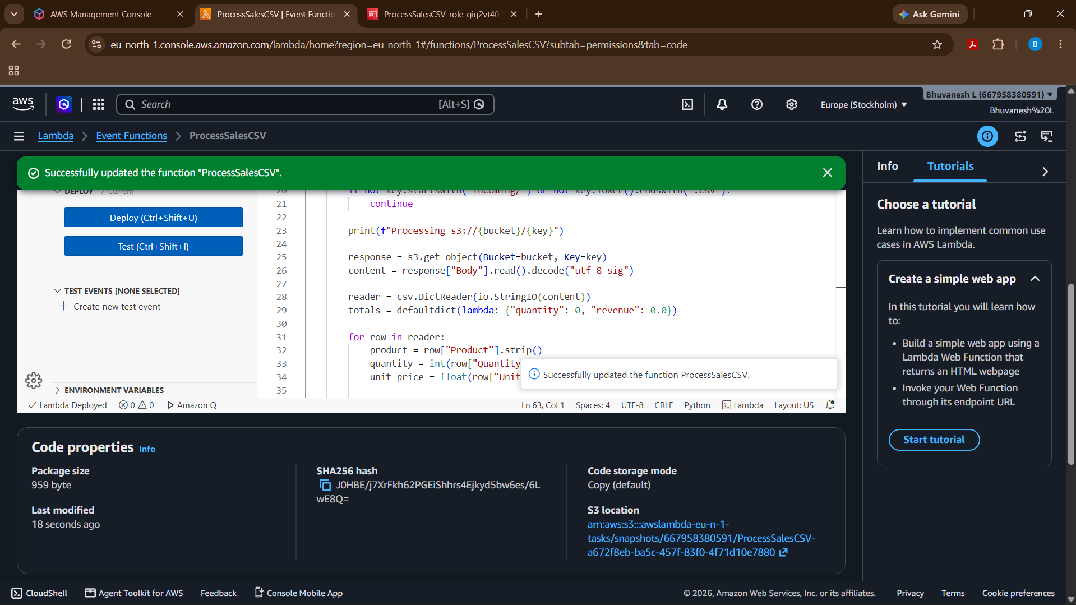

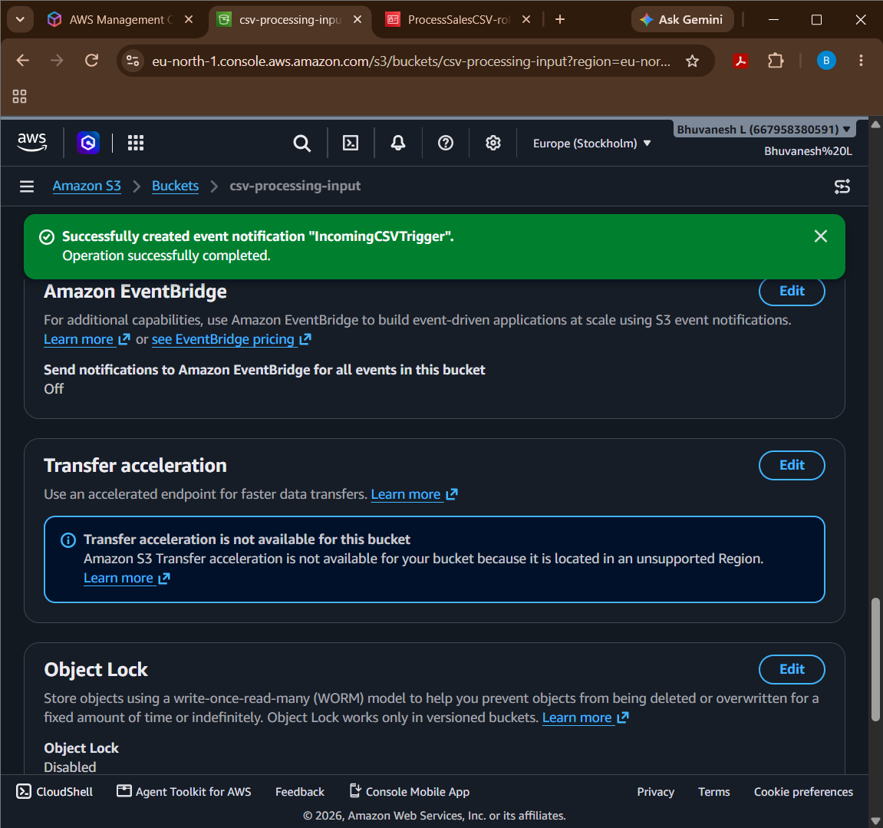

Explain errors and logs
- Amazon CloudWatch Logs records Lambda execution messages, errors, and stack traces.
- Lambda's Monitor tab helps identify invocation failures and execution duration.
- For transient failures, configure appropriate retries and a dead-letter queue or destination where suitable.
- Use the logs to diagnose invalid CSV data, missing permissions, and failed S3 operations.

Prevent duplicate processing and recursive triggers
- Prevent recursive triggering: Configure the S3 notification with prefix incoming/ and suffix .csv. Write outputs to processed/, outside the triggering prefix.
- Prevent duplicate processing: S3 events can be delivered more than once. Make processing idempotent—for example, track processed object keys and version IDs in DynamoDB, or use a durable idempotency key to avoid applying the same transaction twice.
- Handle retries safely: Ensure a retry doesn't create incorrect duplicate business results. Use deterministic output keys and design writes to be repeatable.

SECTION E: AWS STEP FUNCTIONS
Question 13: State Machine Design
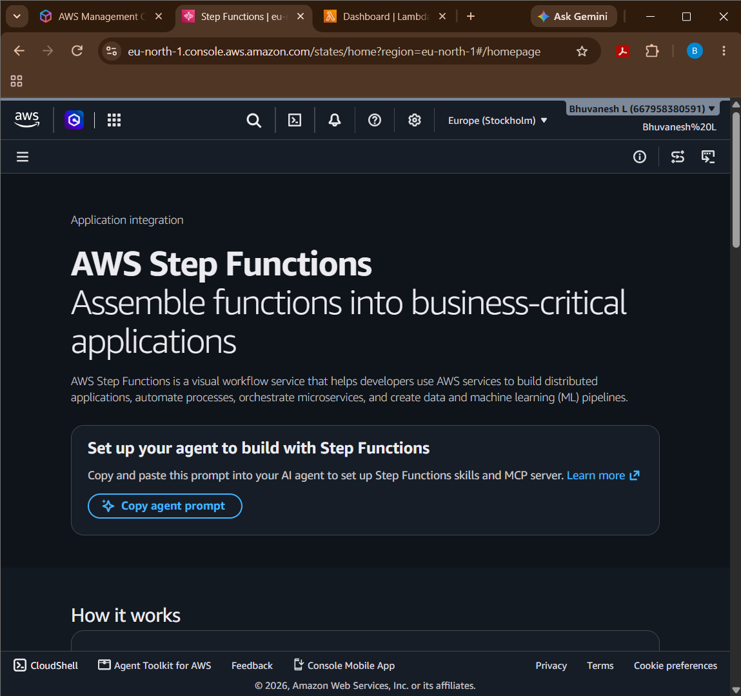

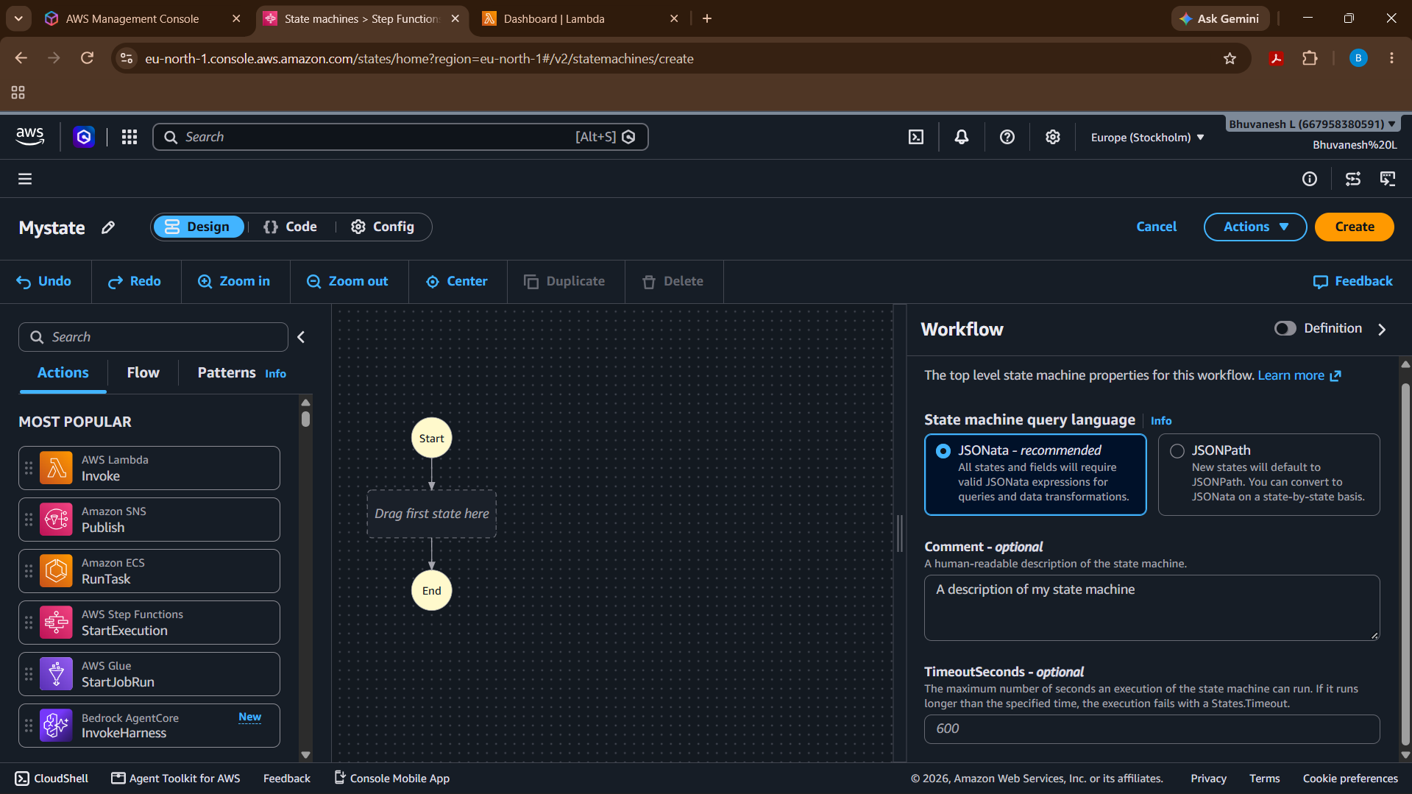
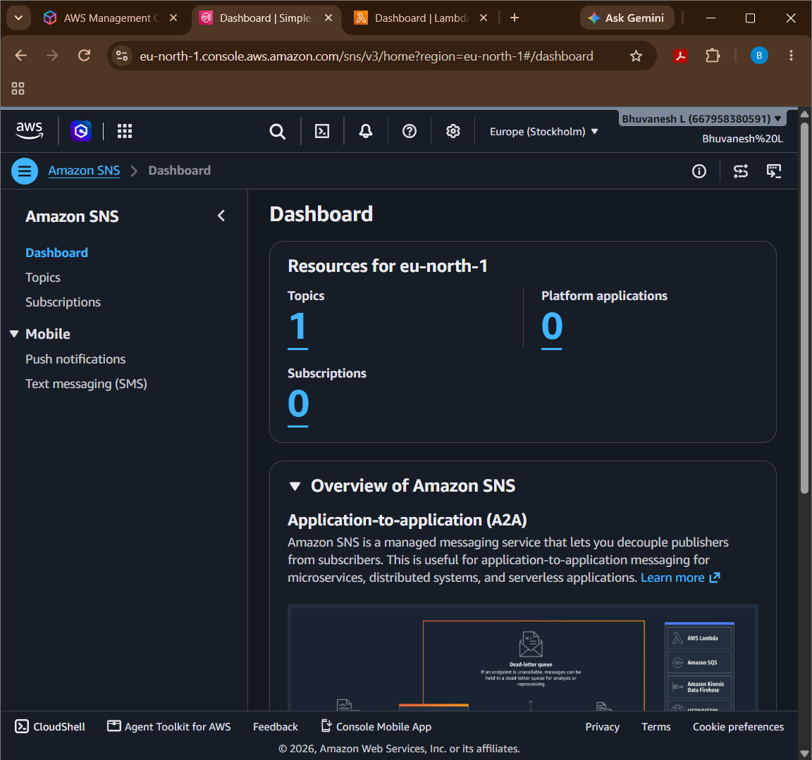

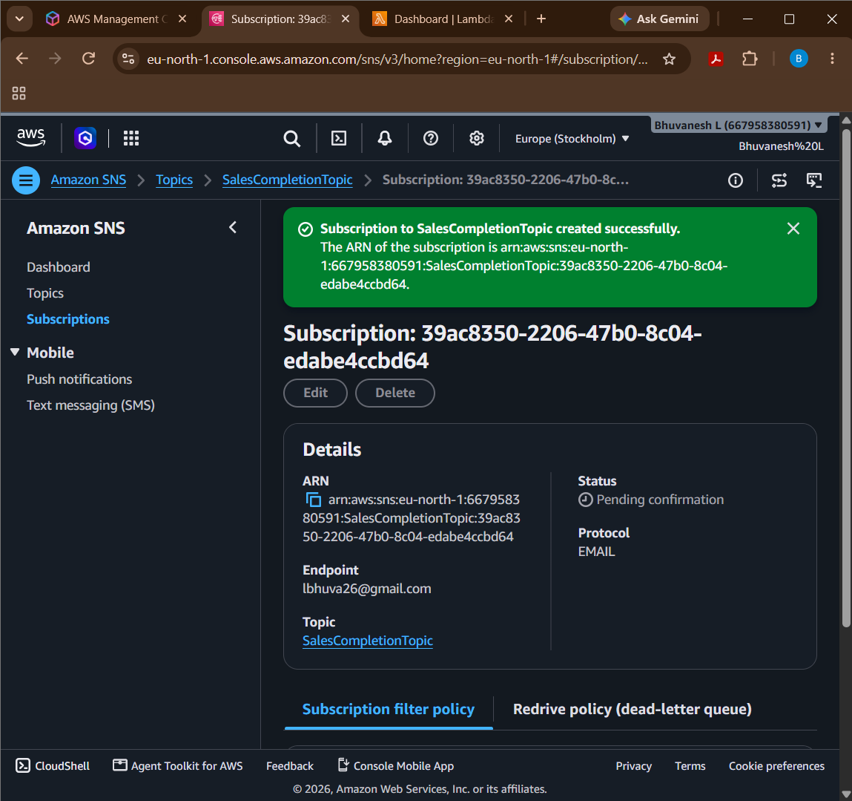

Execute and Verify the State Machine
Open the AWS Step Functions console and select the created state machine. Click Start execution and enter the input JSON containing the S3 bucket name and CSV file path, such as incoming/sales.csv. Replace the sample bucket name with your actual S3 bucket name and click Start execution. Monitor the execution graph to ensure that the ValidateInput, CheckValidation, TransformData, CalculateSales, StoreResults, and SendNotification states complete successfully. Finally, open the S3 bucket's processed/ folder and verify that sales_summary.csv has been created. Check your email for the SNS completion notification to confirm that the workflow has finished successfully.

Question 14: Step Functions Implementation

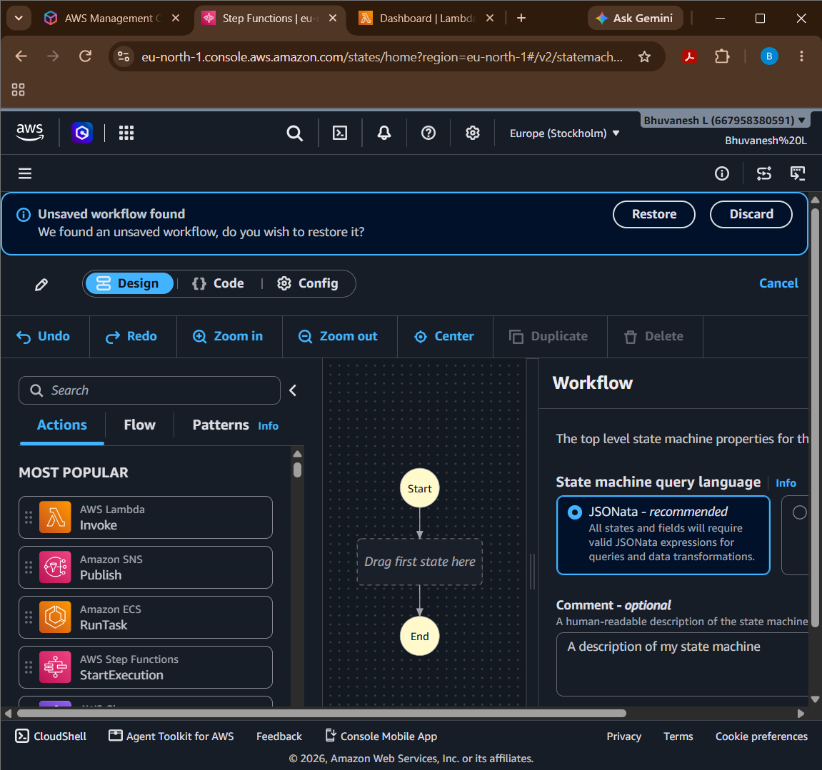

Explain how data from one task is passed to the next task.
In AWS Step Functions, data is passed between tasks as JSON input and output. The output of one task becomes the input of the next task. The ResultPath field stores a task's result in the execution data, while Payload.$ passes the current JSON data to a Lambda function. This allows each task to use the results produced by previous tasks during workflow execution.

e. Explain how you would test successful and failed executions.
To test successful execution, start the state machine with valid input data and verify that ValidateFile, TransformData, and LoadResults execute in sequence and finish successfully. To test failed execution, provide invalid input to make validation fail, simulate a temporary transformation error to verify retries, and simulate a loading error to verify that the Catch transition records the failure. Check the AWS Step Functions execution history to inspect state transitions, retry attempts, and error details.

SECTION F: MICROSOFT AZURE
Question 15: Azure Data Lake Storage and Security

Step 1: Open Azure Portal
Open the Microsoft Azure Portal and sign in using your Azure account. Search for Storage accounts in the top search bar and select the service to begin creating a storage account.

Step 2: Create a Storage Account
Click Create and select your subscription and resource group. Enter a globally unique storage account name, choose a region, select Standard performance, and configure the required redundancy option.

Step 3: Enable Hierarchical Namespace
In the Advanced tab, find the Hierarchical namespace option and enable it. This feature enables Azure Data Lake Storage Gen2 capabilities, including directory-based organization and file-system semantics. Click Review + create, validate the configuration, and click Create.

Step 4: Create a Container
After deployment, open the storage account and navigate to Data storage → Containers. Click + Container, enter the name salesdata, and set the anonymous access level to Private (no anonymous access). Click Create to create the container securely.

Step 5: Create a Sample Dataset
Open Notepad on your computer and enter sample employee data with columns such as EmployeeID, EmployeeName, Department, and Salary. Save the file as employees.csv, selecting All files in the Save As dialog if necessary.

Step 6: Upload the Dataset
Open the salesdata container in Azure Portal and click Upload. Browse your computer, select employees.csv, and click Upload. Verify that the uploaded file appears in the container.

Step 7: Configure Access Using Microsoft Entra ID and Azure RBAC
Open the storage account and select Access control (IAM). Click Add → Add role assignment, select the Storage Blob Data Reader role, and choose the authorized user or group from Microsoft Entra ID. Click Review + assign to apply the permissions.

Step 8: Verify Authorized Access
Sign in as the authorized user or use an authenticated storage client. Open the salesdata container and attempt to read or download employees.csv. Confirm that the user can access the dataset with the assigned read-only permissions.

Step 9: Verify Unauthorized Access
Use a separate test identity that has no applicable data-access permissions. Attempt to access the same dataset and confirm that Azure denies access. Keep the container private and check for any inherited roles or other permissions that might grant access.

Question 16: Azure VM Troubleshooting

Step 1: Verify VM Provisioning and Power State
Open the Azure Portal and navigate to Virtual Machines. Select the required VM and check its provisioning status and power state. Ensure that the VM is successfully provisioned and running.

Step 2: Check Network Security Group (NSG) Rules
Open the VM's Networking settings and review the associated NSG rules. Check whether the required inbound and outbound ports are allowed. Incorrect rules may block connectivity to the VM.

Step 3: Verify Subnet and Routing Configuration
Check the virtual network and subnet assigned to the VM. Review the route table and verify that traffic is directed to the correct destination. Incorrect subnet or routing configurations can prevent network communication.

Step 4: Use Azure Network Troubleshooting Tools
Use Azure Network Watcher to diagnose connectivity issues and inspect effective security rules. Identify blocked traffic and correct the relevant network configuration. Test the connection again after making changes.

Step 5: Follow Secure Troubleshooting Practices
Avoid exposing VM management ports directly to the public internet. Use Azure Bastion for secure SSH or RDP access and restrict network access to trusted sources. Apply the principle of least privilege.
Question 17: Azure Data Integration

Step 1: Create Azure Data Factory
Open the Azure Portal and search for Data Factory. Create a Data Factory instance by selecting the subscription, resource group, region, and name. Open Azure Data Factory Studio to create and manage pipelines.

Step 2: Connect CSV Files to ADLS Gen2
Create a linked service to connect Azure Data Factory to Azure Data Lake Storage Gen2. Configure the source dataset to read daily customer transaction CSV files. Set the destination dataset to the required storage container.

Step 3: Organize Data into Date-Based Folders
Configure the pipeline to store files in date-based folders, such as year=2026/month=10/day=28. This structure helps organize daily transaction data. It also makes searching and processing data for specific dates easier.

Step 4: Handle Malformed and Missing Records
Validate CSV records for missing values, incorrect data types, invalid dates, and missing required fields. Separate invalid records from valid records during processing. Store rejected records in a separate quarantine folder for further investigation.

Step 5: Monitor Pipeline Execution
Open the Monitor section in Azure Data Factory Studio to check pipeline status. Review failed activities, error messages, and execution details. Configure alerts for failures so that issues can be identified and resolved quickly.

Step 6: Validate the Output Data
Check the processed files in ADLS Gen2 to confirm that records are stored correctly. Compare the source, successfully processed, and rejected record counts. Verify that valid data is stored in the correct folders and invalid records are separated.

